Diamond Rings

The following scatterplot contains the prices of ladies' diamond rings and the carat size of their diamond stones. All of the rings are made with gold of 20 carats purity and are each mounted with a single diamond stone. A line of best fit has also been added to the scatterplot. The equation for this line is as follows:

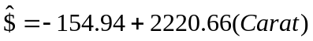

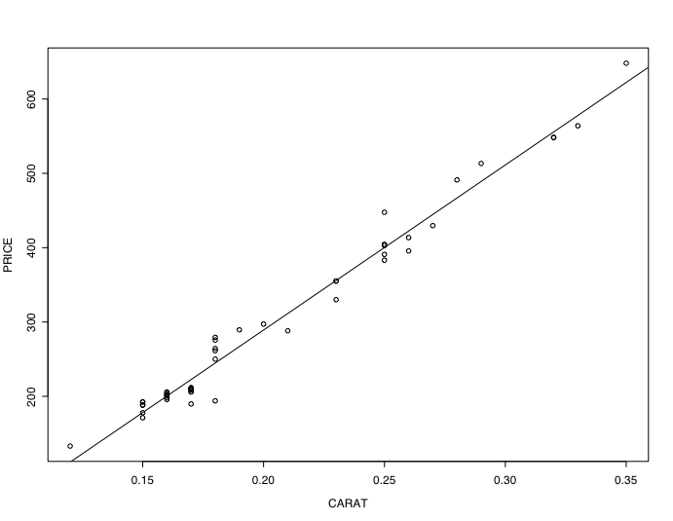

1. Does the line of best fit seem like a good model for the data? Explain.

2. What is the slope for the line of best fit depicted in the scatterplot?

3. What does the slope tell us? (Hint: Interpret what the number means given the data that you are looking at.)

4. What is the y-intercept for the line of best fit depicted in the scatterplot?

5. What does the y-intercept tell us? (Hint: Interpret what the number means given the data that you are looking at.)

6. Does this y-intercept make sense given your interpretation in Question 5? Explain.

Reference

Chu, S. (2001, July). Pricing the C's of diamond stones. Journal of Statistics Education, 9(2). Retrieved December 6, 2006, from http://www.amstat.org/publications/jse/v9n2/datasets.chu.html

