Free Throws

In the Introduction to Monte Carlo Simulation course activity, you used a model of a population to randomly generate outcomes for a sample of data. The sample of data was then summarized using a mean, count, proportion, etc. This process was then repeated a number of times and the distribution of the sample’s summaries was then examined to study the variation that would be expected based on the data generating process (DGP). This assignment will give you more practice with using Monte Carlo simulation to study the variation in sample summaries.

Modeling Free throws

One real-life situation that can be modeled as a random process is free throw shooting in basketball. As with most real-life situations, it can be hard to envision this as a random process—and in fact not all properties of free throw shooting are random. For example, free throws are practiced and players spend differing amounts of time in practice taking free throws. However, in the long run, you would expect that a pattern would emerge that would describe the variation in players’ made and missed free throw shots (i.e., free throw percentage). However, the individual outcome every time a player goes to the free throw line is uncertain (she might make the shot or she might miss). Because of this, free throw shooting can be modeled as a random process.

In 2015 a typical player in the WNBA made 52 free throw attempts and was a 75.4% free throw shooter. In other words, of the 52 free throws attempted during the 2015 season, the typical WNBA player made 75.4% of the free throw attempts, and missed 24.6% of those attempts. The percentage of free throws that were made is referred to as the player’s “free throw percentage”.

- Use TinkerPlots™ to set up a sampler based on a typical WNBA player—assume this player makes 52 free throw attempts and has a free throw percentage of 75.4%.

- Copy and paste a picture of your TinkerPlots™ sampler into your word-processed document

- Click the sampler’s Run button to randomly generate the outcomes for 52 free throw attempts.

- When we carry out a trial of the simulation (click Run), we can think of this as generating the outcomes for 52 free throw attempts for a hypothetical “WNBA player”. (Every time we run the simulation we would be generating data for another hypothetical WNBA player.) Plot the outcomes for this hypothetical WNBA player. Be sure to separate the outcomes and vertically stack them. Also compute the number (count) of made and missed free throws for this player. Copy and paste this plot (with the displayed counts) into your word-processed document.

Carry Out Multiple Trials of the Simulation

- Record the number of free throws that were made for the hypothetical player on a piece of paper. Carry out this process for 49 more hypothetical WNBA players, each time recording the number of free throws that were made on your piece of paper. You should have 50 results (counts) when you are done.
- Open a new TinkerPlotsTM document and drag a case table from the toolbar into your workspace. Enter the 50 counts you recorded into the case table.
- Plot the 50 results (counts) for your 50 hypothetical WNBA players. Be sure to fully separate the plot (no bin lines) and vertically stack the results.

- Copy and paste the plot of the results from your 50 trials into your word-processed document.

- Using the context of basketball, what does a dot in this plot represent?

- Highlight the plot by clicking on it, and select the Averages (Mean) button in the upper toolbar (the triangle). This should add a triangle to your plot underneath the mean value.

- Give the mean value for your 50 results.

- By referring to the model you set up in your TinkerPlotsTM sampler, explain how you could have predicted what the value of the mean would be before looking at the plot.

- Based on the plot of the 50 results, describe the variation in the number of free throws made by giving the endpoints of the range where most counts lie in the plot.

- What percent of the 50 results fall in the range you provided in Question #7? Explain. (Hint: If your endpoints do not encompass more than 50% of the results, go back to Question #7 and redefine them.)

Percentiles

A percentile is a measure used in statistics to indicate the value below which a given percentage of observations in a group of observations fall. For example, the 20th percentile is the value (or score) below which 20% of the observations may be found. We can easily find the percentile value using TinkerPlot’sTM Divider tool.

- Highlight the plot of the 50 results by clicking on it. Select the Divider tool from the toolbar. This should add a shaded rectangle to your plot.
- Now click the % (percent) tool in the toolbar. This should add three percentages to your plot. These percentages correspond to the percentage of cases in each of the three areas defined by the divider (the left-side of the shaded area, in the shaded area, and the right-side of the shaded area).
- Drag the left-side of the shaded area all the way to the left-hand side of the plot (the area to the left of the shaded area should have a percentage of zero).
- Drag the right-side of the shaded area so that the percentage in the shaded area is the percentile you want. For example, the figure below shows how to find the 61st-percentile.
- To determine the value that is at the 61st-percentile, add a vertical reference line to the plot by clicking the vertical ref. line button in the toolbar. Move the reference line to the right edge of the shaded area. Below, the value of 215.8 is at the 61st-percentile.

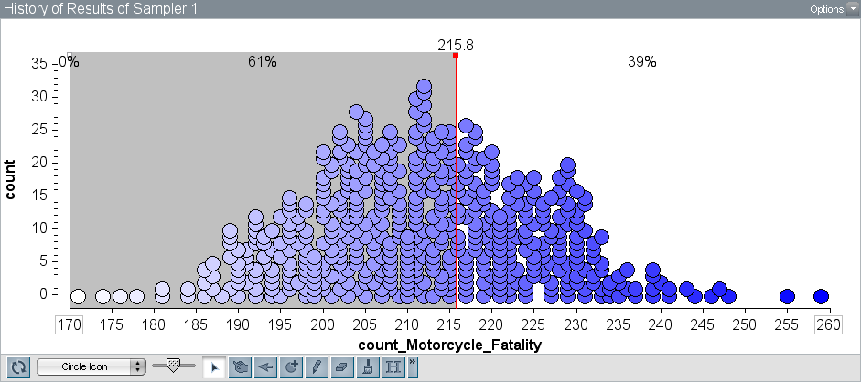

- Use the divider tool and reference line to find the number of free throws made for a WNBA player at the 75th percentile. Copy and paste the plot of results (with the divider and reference line) into your word-processed document.

- In 2015, Minnesota Lynx player Maya Moore made 85.5% of her free throw attempts. In our plot, this would be equivalent to a WNBA player making 44 of 52 attempts. Use the divider tool and reference line to find the percentile for a WNBA player that makes 44 of 52 free throws. Copy and paste the plot of results (with the divider and reference line) into your word-processed document.

- In 2015, Chicago Sky player Elena Delle Donne made 95% of her attempted free throws. In our plot, this would be equivalent to a WNBA player making 49 of 52 attempts. Use the divider tool and reference line to find the percentile for a WNBA player that makes 49 of 52 free throws. Copy and paste the plot of results (with the divider and reference line) into your word-processed document.

- ESPN called Elena Delle Donne’s free throw percentage of 95% “astonishing”. Based on your answer to Question #11, is a WNBA player who makes 95% of her free throw attempts “astonishing”? Explain by referencing your simulation results.

