|  |
| --- |
| **Swimming with Dolphins and Pigs!** |

Recall the Dolphin Therapy study. You learned that 10 of the 15 subjects (66.7%) who swam with dolphins showed substantial improvement in their depression symptoms at the end of the study, compared to 3 of the 15 subjects (20%) who swam without dolphins. You found strong evidence against the null model. A natural follow-up question is:



How much larger is the improvement rate

in swimming with dolphins compared

to swimming without dolphins?

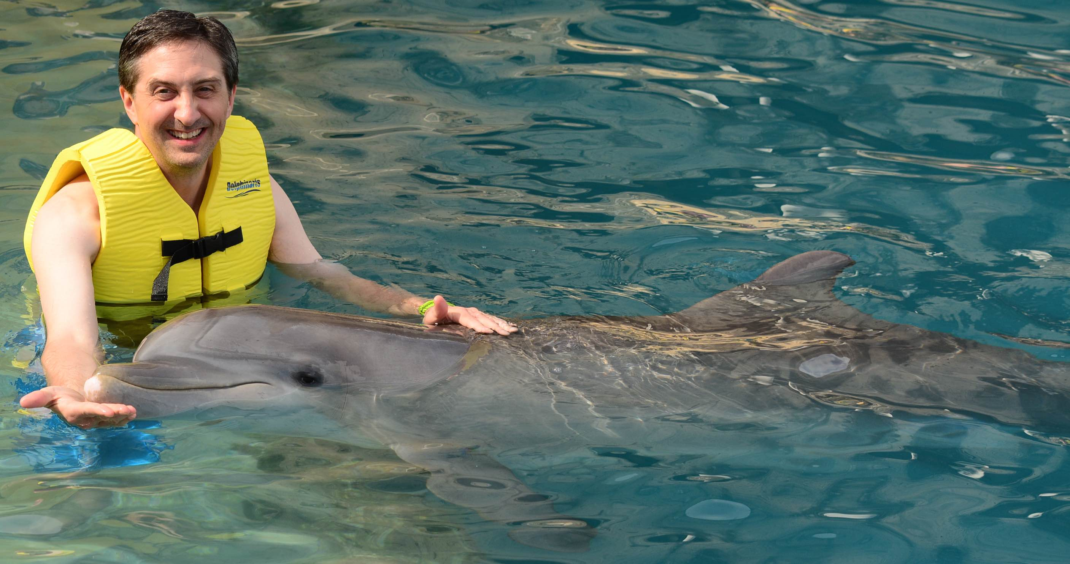

**Bootstrap Interval Estimates for Swimming with and without Dolphins**

Use TinkerPlots™ to estimate the size of the effect (i.e., difference between the two population percentages) with a bootstrap interval (see instructions in the margin). Plot each group separately and collect 500 trials for the percentage of treatment subjects (*Dolphins*) who improved and the percentage of control group subjects (*NonDolphins*) who improved. Create a table of each of the percentages for the 500 trials and make a plot of the 500 bootstrapped trials for both groups.

**Setting up the Models**

* Drag a Sampler from the object toolbar into the blank document.
* Create two linked Stacks in the sampler device.
* Name the first mixer *Dolphins.* Name the second mixer *NonDolphins*.
* In the *Dolphin* Stack device, put in 10 elements labeled *improvement* and 5 elements labeled *none*.
* In the *NonDolphins* Stacks device, put in 3 elements labeled *improvement* and 12 elements labeled *none*.
* Change the Repeat value to 15. The two devices can be in one sampler window because each group has the same number of subject. (This means the Draw value should be 2.)
* Set the replacement to with replacement for both mixers.
* Click the RUN button to randomly select 15 observations from each group.

1. Copy-and-paste your linked sampler into your word-processed document.
2. Copy-and-paste the plot of both bootstrap distributions into your word-processed document – the *Dolphins* and the *NonDolphins* groups.
3. Compute and report the mean of each bootstrap distribution. Explain why you could have predicted these values based on the models in your TinkerPlotsTM sampler.
4. Compute and report the standard errors for each of the two bootstrap distributions.
5. Compute and report the interval estimates for both bootstrap distributions. Show all parts of your calculations.
6. Draw the ranges of both interval estimates using an axis such as the one below. Label which interval is for the dolphin group and which is for the non-dolphin group.



1. Based on your interval estimates, does this study provide plausible evidence to suggest that swimming with dolphins yields a higher percentage of improvement, on average, than swimming without dolphins? Explain your reasoning.

**Bootstrap Interval Estimate for the Difference in Percentages**

Add a column in your TinkerPlots™ results table to calculate the difference in percentages between the between the treatment group (*Dolphins*) and the control group (*NonDolphins*) for the 500 trials and plot the 500 bootstrapped differences.

1. Copy-and-paste the plot of the bootstrapped difference in percentages into your word-processing document.
2. Compute and report the mean of the bootstrap distribution. Explain why you could have predicted this value based on the model in your TinkerPlotsTM sampler.
3. Compute and report the standard error for the bootstrap distribution of the difference in means.
4. Compute and report the interval estimate for the difference in means. Show all parts of your calculation.
5. Answer the research question posed at the beginning of the assignment:

How much larger is the improvement rate in swimming

with dolphins compared to swimming without dolphins?

Use evidence from the bootstrap analysis to support your answer.

1. Jose is convinced that the “true” difference between Dolphin and Control groups is actually 70%. Based on your confidence interval, is it plausible that Jose’s parameter value is correct?

**Interval Estimate: Dolphins vs. Pigs**

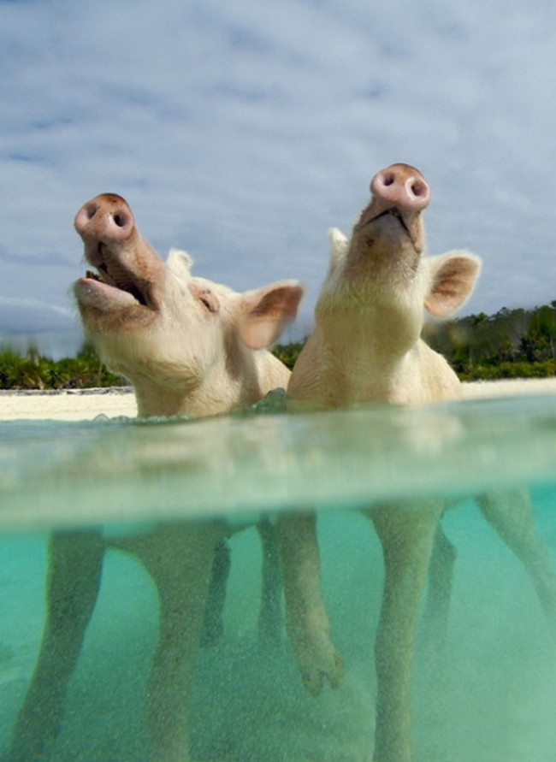In a critique of Dolphin Therapy Studies, Marino & Lilienfeld (2007)[1] argue that research on dolphin therapy fails to take into account whether swimming with other large animals improves depression. Marin & Lilienfeld suggest that the active ingredient is not swimming with dolphins, but rather swimming with any animal in water.

Exuma in the Bahamas is known to have friendly wild pigs that join tourists on the beach and will join them for a swim in the water.

(For a video of the swimming pigs see: <https://www.youtube.com/watch?v=O89DvVdthDY#t=42>).

To investigate whether dolphins are better than other animals, suppose that researchers also randomly assigned depression patients to a third group: swimming with pigs. Suppose the pigs treatment group resulted in 58% improvement with a margin of error of 13%. A bootstrap procedure reveals a standard error of 6% for the difference in percentage of improvement between the pig and dolphin groups.

1. Based on these results, compute and report the interval estimate for the percentage of subjects in that swam with pigs who showed substantial improvement in their depression symptoms.
2. Draw the range of the interval estimate for the pig group using the same axis as in Question 6. Label this interval as the pig group.
3. Based on your interval estimate, does this study provide plausible evidence to suggest that swimming with dolphins yields a higher percentage of improvement, on average, than swimming with pigs? Explain your reasoning.
4. Based on the same data, Oliver conducts a hypothesis test and rejects the null hypothesis of no difference between the treatment groups (swimming with dolphins and swimming with pigs). Is Oliver’s result consistent with the results of your interval estimates from above? Explain.

1. Marino, L., & Lilienfeld, S. O. (2007). Dolphin-assisted therapy: More flawed data and more flawed conclusions. *Anthrozoos: A Multidisciplinary Journal of The Interactions of People & Animals*, *20*(3), 239-249.