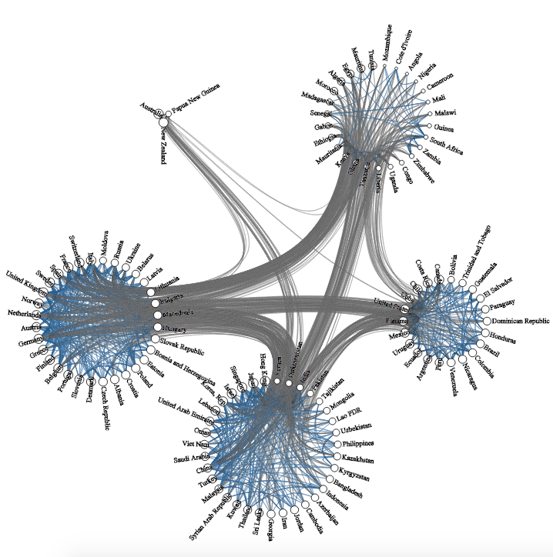 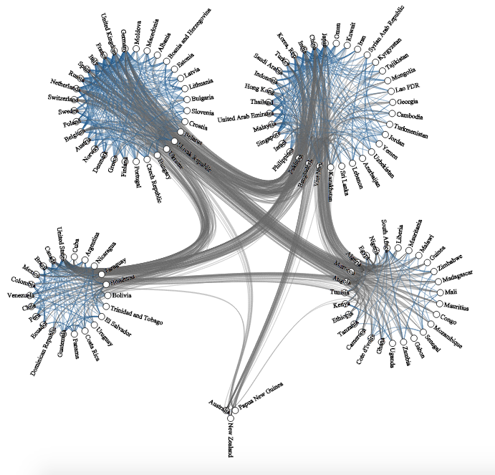

Arranged continents by geographical location

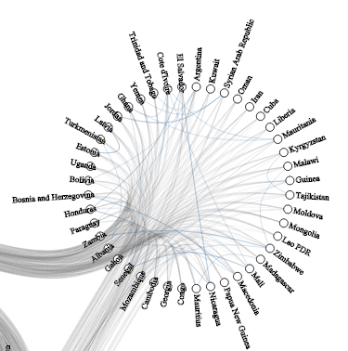 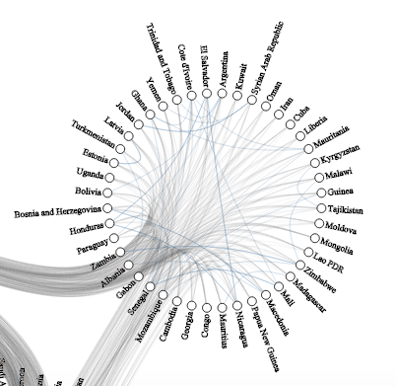

Problem with labels

Had to make circles with less items bigger

Colour line thickness => trade between countries

Low gdp countries dependant on high gdp (no trade within)

Begründung wieso keine Farbe

Fix for group labels

Made blend out tranisiton because smooth animation that allows folling of data was too slow because too many paths are beeing drawn and updated (bundle smoothing)

Explain bug, which preventing me from keeping link selected

* issues I had: outliniers -> log scale
* - questions: which countries are close to this one (lines)
* done:
* - adjust circle size relative to number of items

auto segment deactivitert