# Project Description of Maze Runner Duck

Zigeng Liu

504188798

Dec 4,2015

**Interface:**

In this project, I plan to use the blueprint of the numberMuncher and evolve from it a new game called the Maze Runner Duck.

* Main menu and popup window of instruction:

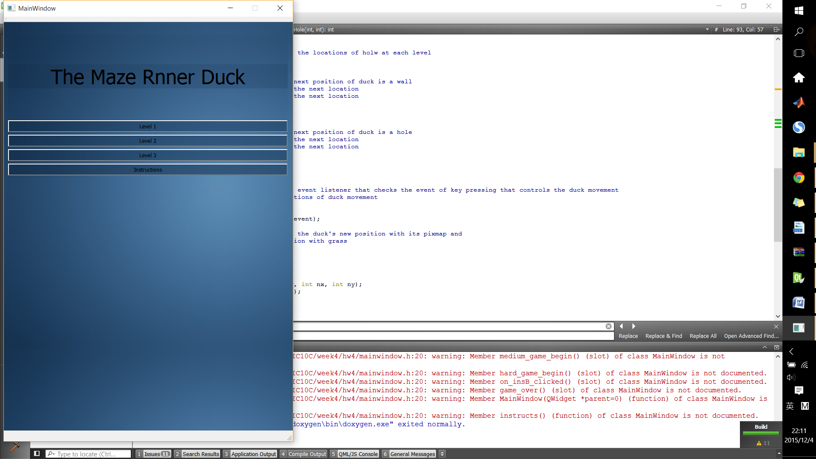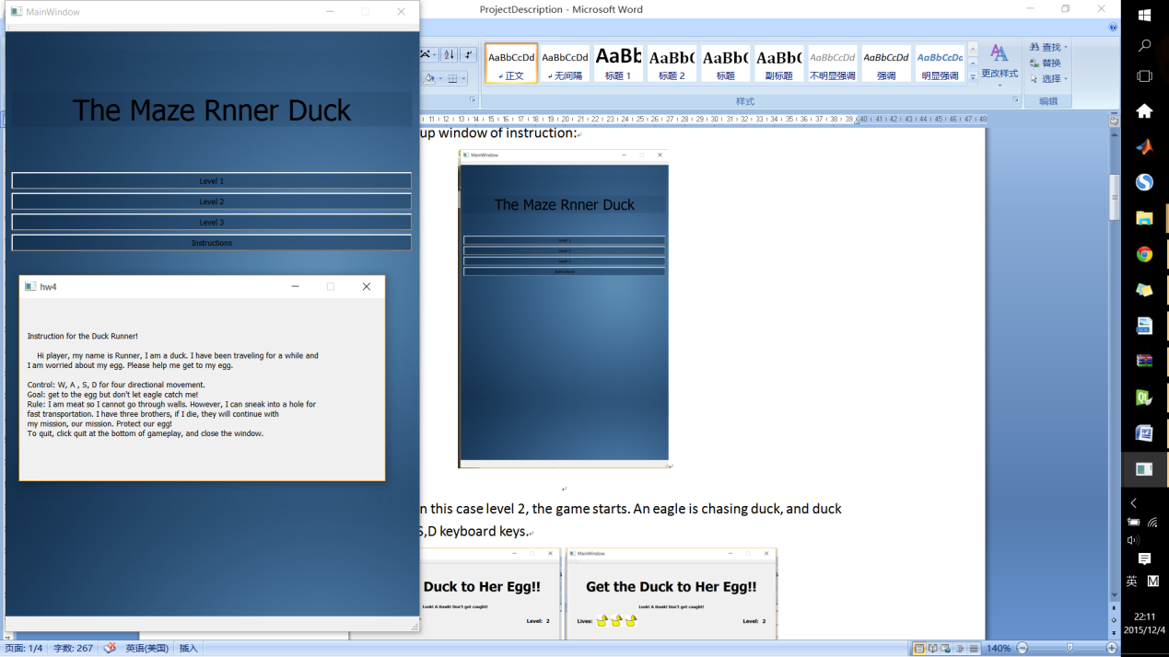

* If any level chosen (in this case level 2, the game starts. An eagle is chasing duck, and duck can move with W,A,S,D keyboard keys.

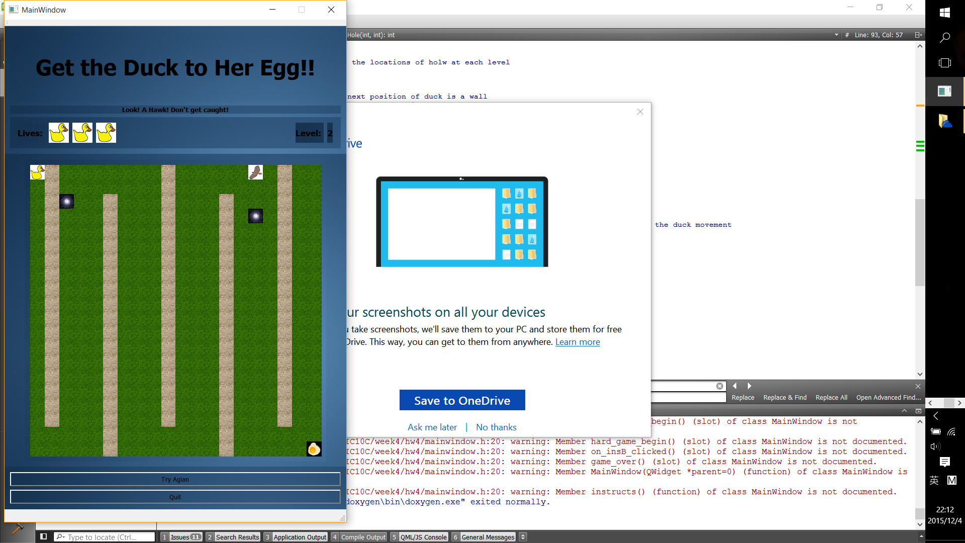

* If the duck get caught by the eagle, a life is lost(duck calls his buddie, but the eagle continues its pursuit). In addition, the duck can go through "holes" but not "walls".

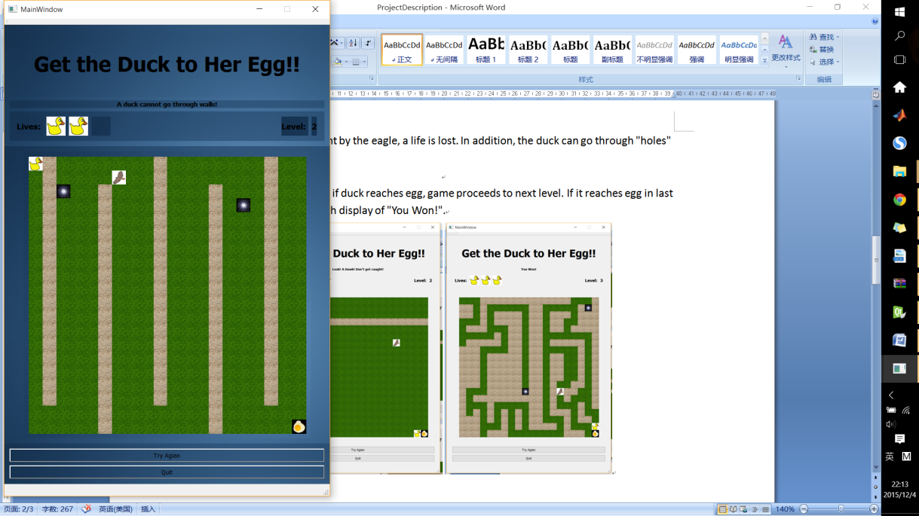

* Winning conditions: if duck reaches egg, game proceeds to next level. If it reaches egg in last level, game ends with display of "You Won!".

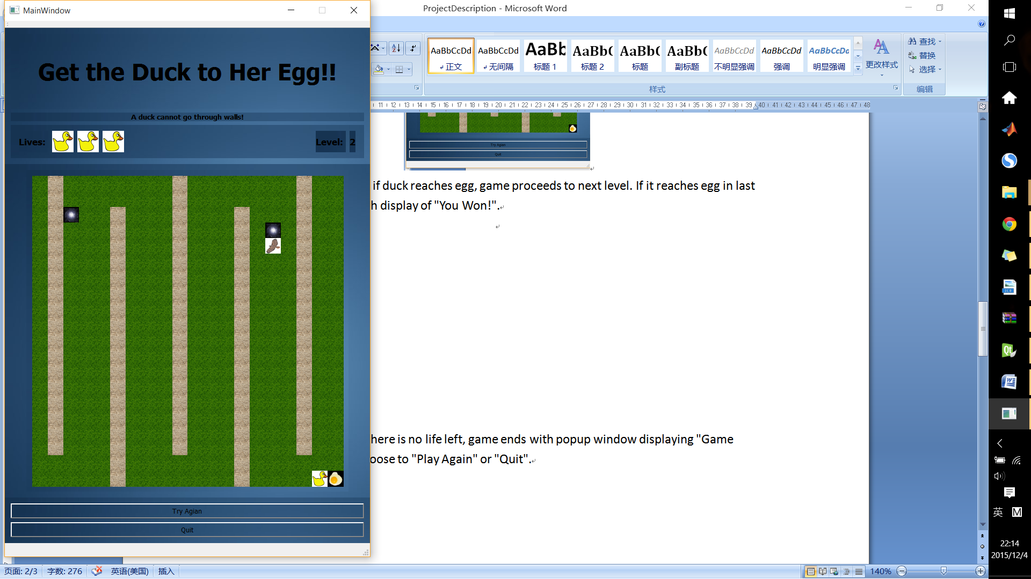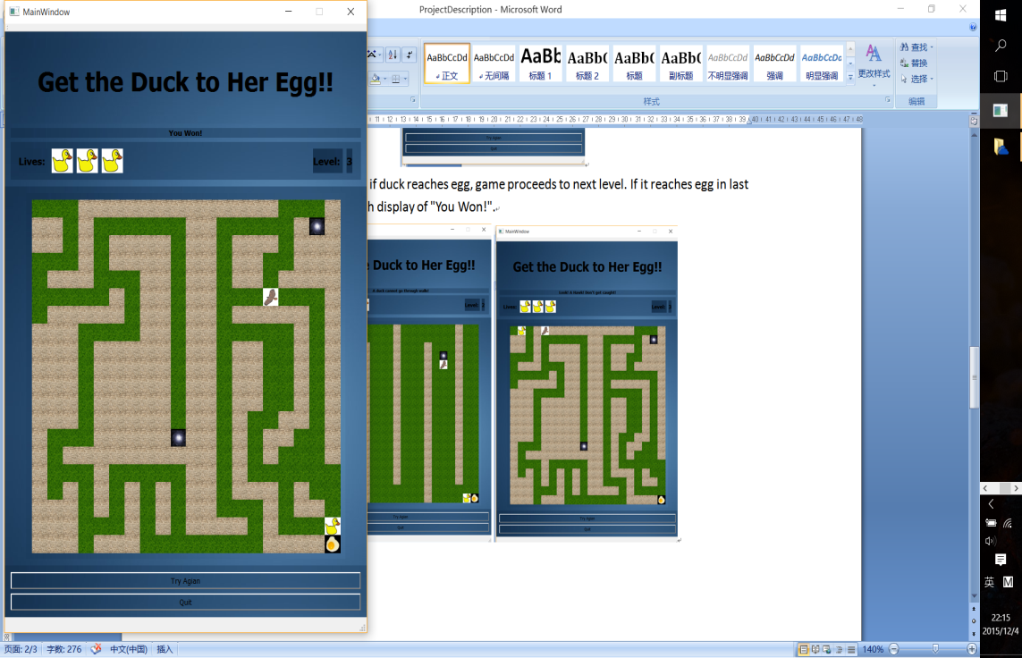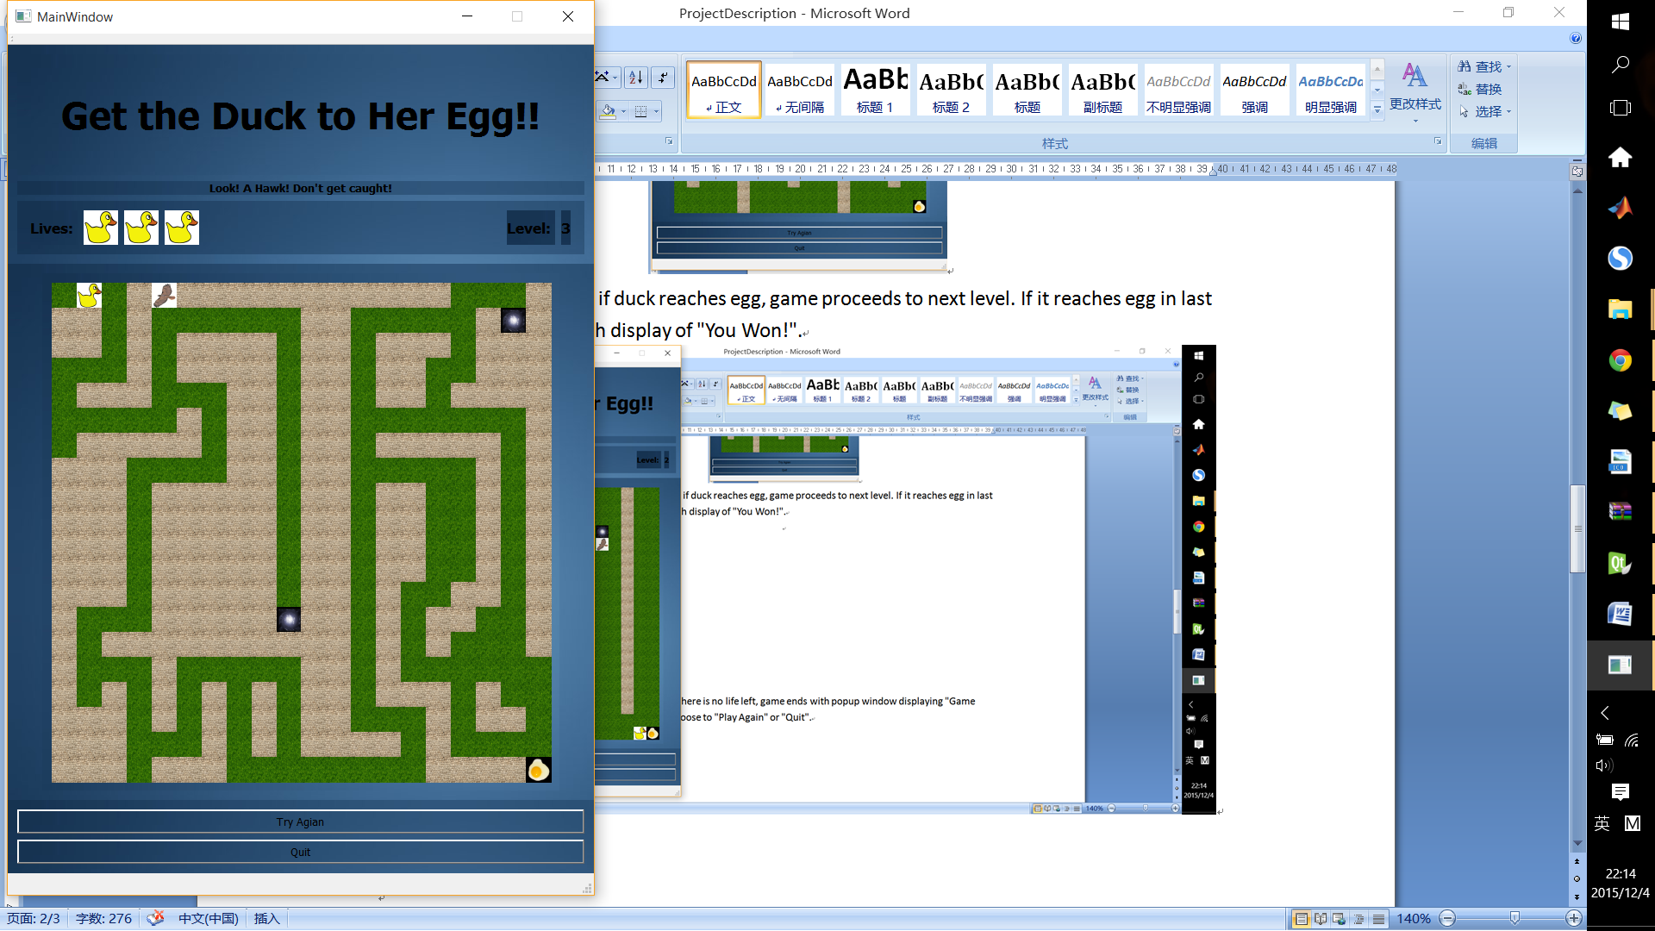

* Losing condition: if there is no life left, game ends with popup window displaying "Game Over". Player can choose to "Play Again" or "Quit".

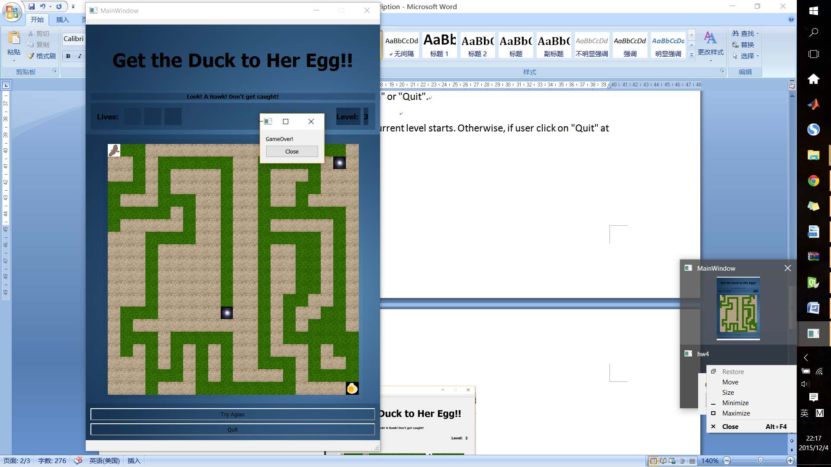

* If click on "Try Again", a new game at current level starts. Otherwise, if user click on "Quit" at the bottom, it returns to main menu.

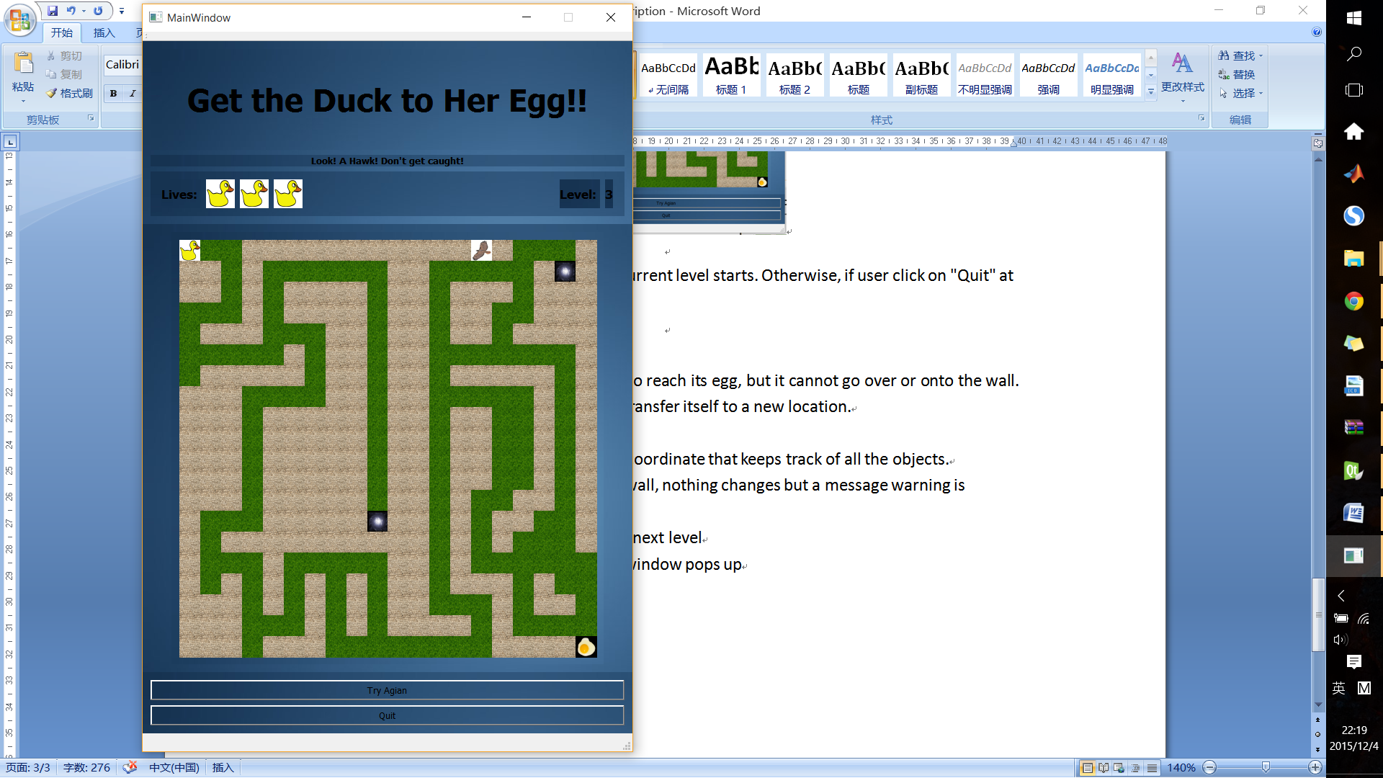

**Logic:**

* The user should control the duck to reach its egg, but it cannot go over or onto the wall. However, it can use the portal to transfer itself to a new location.
* The user should use arrow keys.
* Every label on the grid has a (x,y) coordinate that keeps track of all the objects.
* It the duck hits the coordinate of wall, nothing changes but a message warning is displayed.
* If it reaches egg, game proceed to next level
* If hawk reaches duck, game over window pops up