# Financial Report by Category

---------------------------

## Incomes

**Category: Active** - Gamer: $900.00  
*Total for Active: $900.00*

**Category: Passive** - Underwater Basket Weaving Instructor: $135.00  
*Total for Passive: $135.00*

**Total Income: $1035.00**

---------------------------

## Expenses

**Category: Food/Beverage** - The Root: $3100.00  
 - Uranium: $2250.00  
 - Eating Out: $10.00  
*Total for Food/Beverage: $5360.00*

**Category: Housing** - Rent: $8000.00  
*Total for Housing: $8000.00*

**Category: Transportation** - Gasoline: $1000.00  
*Total for Transportation: $1000.00*

**Total Expenses: $14360.00**

## Visual Summary

Income Distribution:

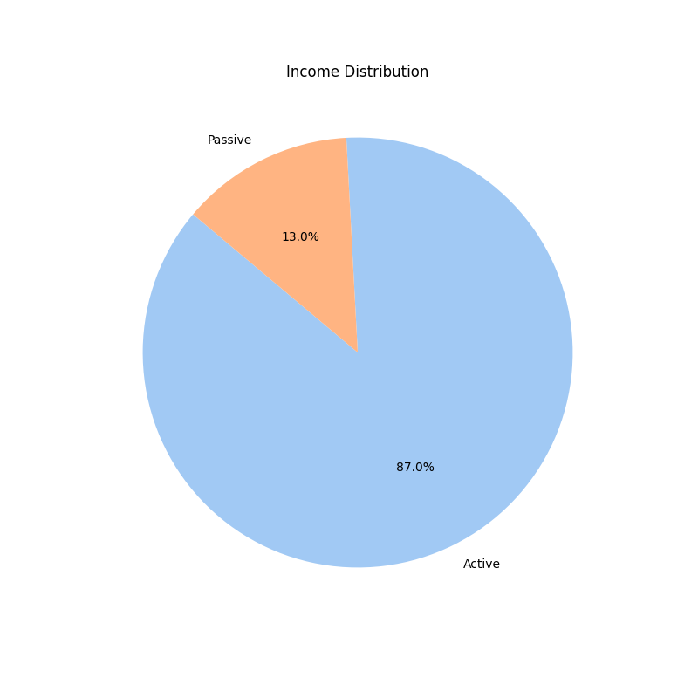

Expense Distribution:

