AZURE Pods Restart Through Azure CLI.

**Type below line then enter**  
az login   
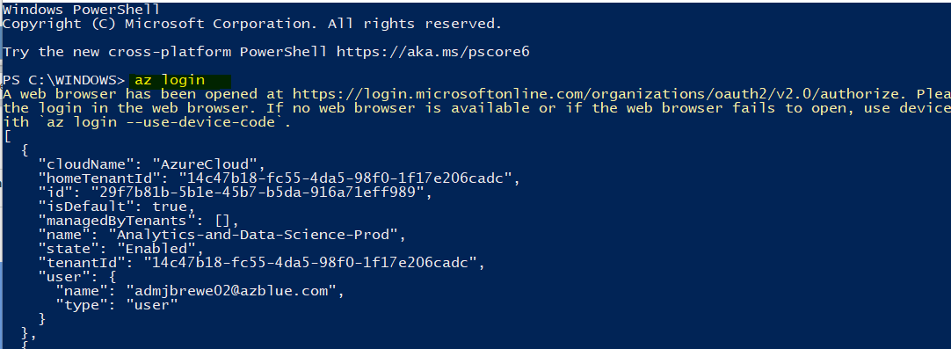

**After that, you have to set the subscription by typing in the below line**  
  
az account set --subscription 1d834cda-73f2-4065-b96d-187dacbc2dd9

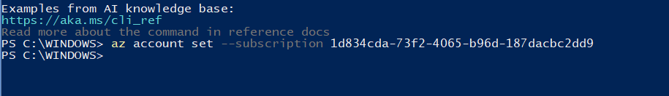  
  
**next type in the below line**  
  
az aks get-credentials --resource-group rgAppP003 --name aksAppP003 --overwrite-existing



**Next type the below line**

kubelogin convert-kubeconfig -l azurecli

**Then type the below line. And you’ll see a list of pods and their status.**

kubectl get pods -n edi-prod

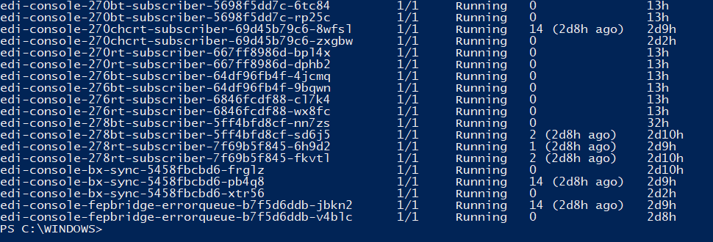

**Then type the line below:**

**kubectl rollout restart deployment -n edi-prod edi-api-interface**

**After the restart query. Check the below PODS to ensure ready state is 1/1 and status is “Running.” Also take a look at the “Restarts” column to make sure it updated with the most current time.**

edi-api-transformer-7bc874bbf5-l5bkb

edi-api-transformer-7bc874bbf5-qg6tj   
edi-api-transformer-7bc874bbf5-xj9pt

**We may get a req to restart edi-console-fepbridge-errorqueue, that script is below.**

kubectl rollout restart deployment -n edi-prod edi-console-fepbridge-errorqueue

***NOTE: Only if having issues with mq’s after patching***

The status of PODS will state, “running” but with mq issues after patching, they will still need to be reset. Below are the ones you will reset and the script to do so. Each line is done independently.

kubectl rollout restart deployment -n edi-prod edi-console-270bt-subscriber

kubectl rollout restart deployment -n edi-prod edi-console-270rt-subscriber

kubectl rollout restart deployment -n edi-prod edi-console-276bt-subscriber

kubectl rollout restart deployment -n edi-prod edi-console-276rt-subscriber