<http://mp-edi-w05:8080/tm/logon/logon.jsp>

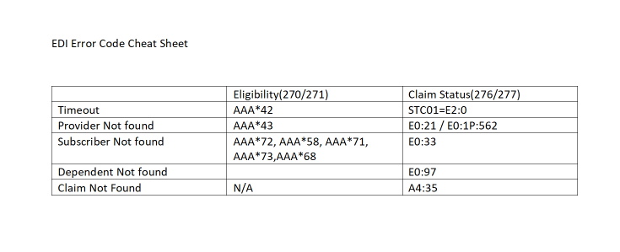

Edifecs and SOAP UI:

EDI engine, process standard transactions - multi year effort to load all

270/271, 276/277  
Dental  
Outbound 834

SOAP UI - API Testing tool, SOAP web services  
-- Connecter service layer is SOAP, HRP data

State of AZ, Medicare  
------------------------

<http://mp-edi-w05:8080/tm/logon/logon.jsp>  
use regular AD  
Check the box to confirm profile

-------

Edifecs portal...

Operating Rules Compliance - Real time  
Clock icon, shows SLA

Claim Status Real time

Cheat sheet: EDI Error Code Cheat Sheet.docx

- AAA 15mins behind the hour - flavor of error within the transactions

42, Provide code could be blank or invlaid  
72, Invalid Subscriber informartion

-------

SOAP UI - Testing HUB API

Any thing over 5 secs is a concern, 8 sec SLA

Caching layer... subsequent request versus the initial request (could be faster)  
AAA \* R42, several lines down in raw data

20s, Edifecs will send its own response of 42

NO response means issue with HRP

\* Import Project, play to submit  
\* Pick a transaction?

.42 - Production