**Steps to run ADF pipeline manually(using Post API) in Prod**

Resource Details:

|  |
| --- |
| Azure Data Factory name: adfFepAdfclaimsodsP001 |
| **Pipeline**: MetavanceStatusDailyUpload |
| **Resource group name**: rgFepAdfclaimsodsP001 |
| **Subscription** Id: Velocity-Connect-Production |

Note: There are 6 Runs required to complete this task, all steps are common except parameters data, please follow the below document for each step:

## Run 1:

Step 1: Open URL in incognito mode.

<https://docs.microsoft.com/en-us/rest/api/datafactory/pipelines/create-run?tryIt=true&source=docs#code-try-0>

Step 2: sign in with ADM AZBlue credentials as mentioned below.

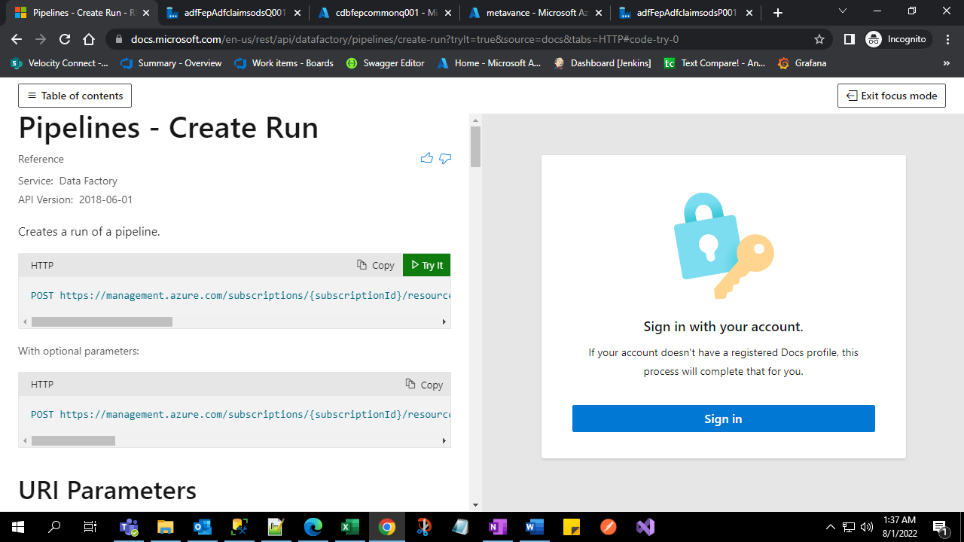

Step 3: Add parameters details for pipeline run as shown below.

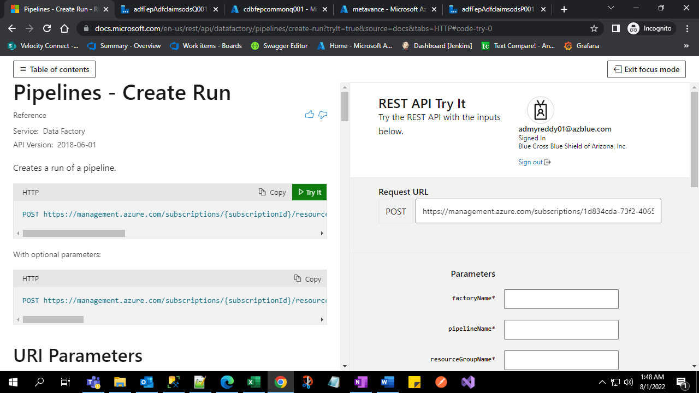

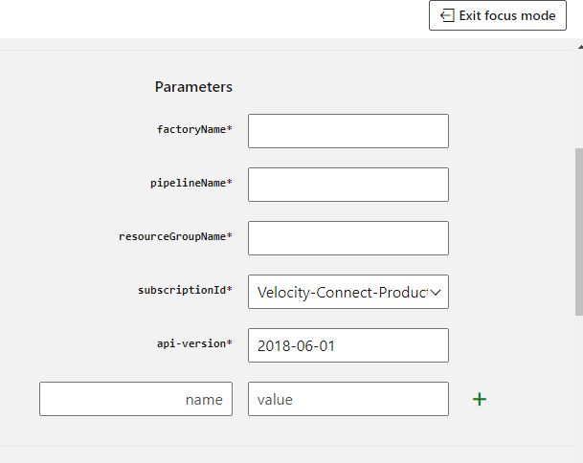

## 

## Values to fill parameters

## Factory name: adfFepAdfclaimsodsP001

**Pipeline**: MetavanceStatusDailyUpload

**resource group name**: rgFepAdfclaimsodsP001

**select Subscription** Id: Velocity-Connect-Production

**add below json in body**

{

"parentStartDate":"2022-01-01 00:00:00.000",

"parentEndDate":"2022-07-31 00:00:00.000"

}

Then click Run:

Once clicked, it returns 200(200 means success code, in this case we need to wait 3-4 hours to run next.

Failure case need to analyze like some time 403, 400 etc.

## Run 2:

Repeat the above steps with other date parameters

{

"parentStartDate":"2021-07-01 00:00:00.000",

"parentEndDate":"2021-12-31 00:00:00.000"

}

## Run 3:

Repeat the above steps with other date parameters

{

"parentStartDate":"2021-01-01 00:00:00.000",

"parentEndDate":"2021-06-30 00:00:00.000"

}

## Run 4:

Repeat the above steps with other date parameters

{

"parentStartDate":"2020-07-01 00:00:00.000",

"parentEndDate":"2020-12-31 00:00:00.000"

}

## Run 5:

Repeat the above steps with other date parameters

{

"parentStartDate":"2020-01-01 00:00:00.000",

"parentEndDate":"2020-06-30 00:00:00.000"

}

## Run 6:

Repeat the above steps with other date parameters

{

"parentStartDate":"2019-11-01 00:00:00.000",

"parentEndDate":"2019-12-31 00:00:00.000"

}

URL – use adm account on Edge

<https://docs.microsoft.com/en-us/rest/api/datafactory/pipelines/create-run?tryIt=true&source=docs&tabs=HTTP#code-try-0>

Pipelines - Create Run - REST API (Azure Data Factory)

Learn more about Data Factory service - Creates a run of a pipeline.

<https://adf.azure.com/en/monitoring/pipelineruns?factory=%2Fsubscriptions%2F1d834cda-73f2-4065-b96d-187dacbc2dd9%2FresourceGroups%2FrgFepAdfclaimsodsP001%2Fproviders%2FMicrosoft.DataFactory%2Ffactories%2FadfFepAdfclaimsodsP001>

Azure Data Factory