**Steps to run ADF pipeline manually (using Post API) in Prod**

Resource Details:

|  |
| --- |
| Azure Data Factory name: adfFepAdfclaimsodsP001 |
| **Pipeline**: MetavanceStatusDailyUpload |
| **Resource group name**: rgFepAdfclaimsodsP001 |
| **Subscription** Id: Velocity-Connect-Production |

Note: There are 13 Runs required to complete this task (due to include of HOME claims we reduce data load from 6 months to 2 months), all steps are common except parameters data, please follow the below document for each step:

## Run 1:

Step 1: Open URL in incognito mode.

<https://docs.microsoft.com/en-us/rest/api/datafactory/pipelines/create-run?tryIt=true&source=docs#code-try-0>

Step 2: sign in with ADM AZBlue credentials as mentioned below.

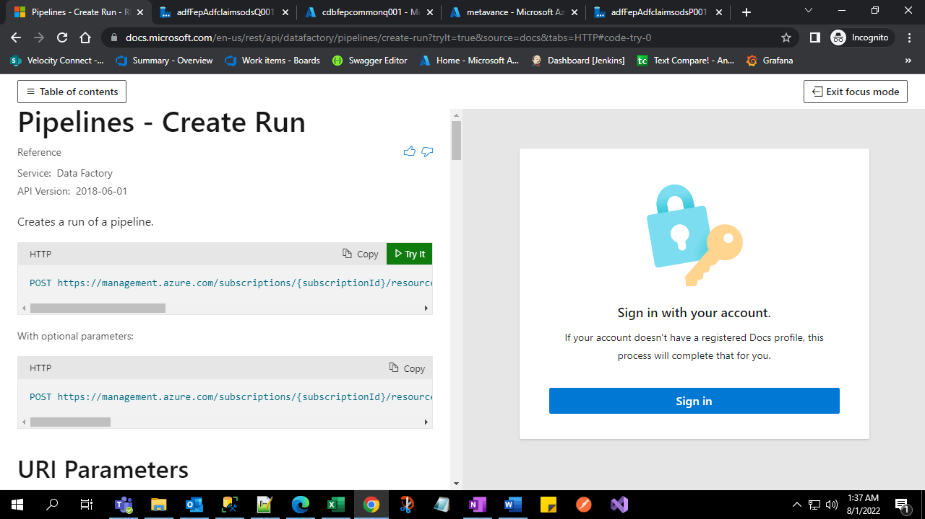

Step 3: Add parameters details for pipeline run as shown below.

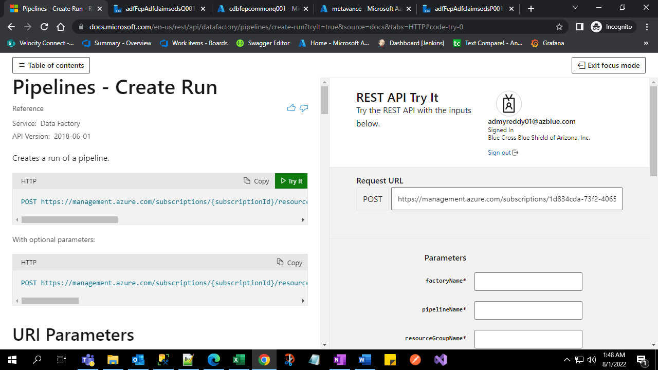

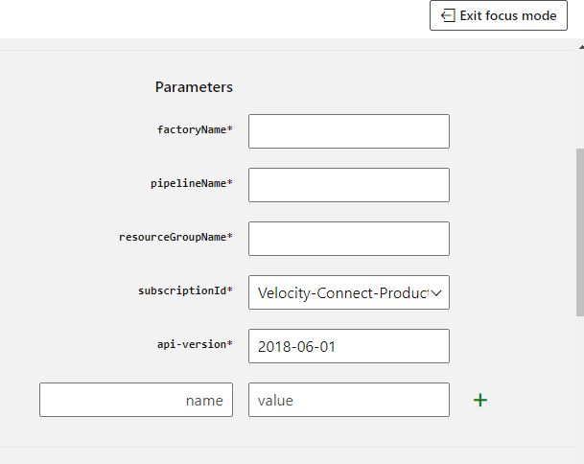

## 

## Values to fill parameters

## Factory name: adfFepAdfclaimsodsP001

**Pipeline**: MetavanceStatusDailyUpload

**resource group name**: rgFepAdfclaimsodsP001

**select Subscription** Id: Velocity-Connect-Production

API -version: no need to add/change

**add below Json in body**

{

"parentStartDate":"2022-12-01 00:00:00.000",

"parentEndDate":"2022-12-31 00:00:00.000"

}

Then click Run:

Once clicked, it returns 200(200 means success code, in this case we need to wait 2-3 hours to run next.

Failure case need to analyze like some time 403, 400 etc. If its failure, please inform to DEV team we will let you know what to be done.

Common Errors:

* *403 response code, please refresh the page and give details freshly and trigger again for those failure date range.*
* *400 response code If we give spell mistakes extra spaces in the parameters, we will get 400 error code.*

## Run 2:

Repeat the above steps with other date parameters

{

"parentStartDate":"2022-11-01 00:00:00.000",

"parentEndDate":"2022-11-30 00:00:00.000"

}

## Run 3:

Repeat the above steps with other date parameters

{

"parentStartDate":"2022-10-01 00:00:00.000",

"parentEndDate":"2022-10-31 00:00:00.000"

}

## Run 4:

Repeat the above steps with other date parameters

{

"parentStartDate":"2022-09-01 00:00:00.000",

"parentEndDate":"2022-09-30 00:00:00.000"

}

## Run 5:

Repeat the above steps with other date parameters

{

"parentStartDate":"2022-08-01 00:00:00.000",

"parentEndDate":"2022-08-31 00:00:00.000"

}

## Run 6:

Repeat the above steps with other date parameters

{

"parentStartDate":"2022-07-01 00:00:00.000",

"parentEndDate":"2022-07-31 00:00:00.000"

}

## Run 7:

Repeat the above steps with other date parameters

{

"parentStartDate":"2022-06-01 00:00:00.000",

"parentEndDate":"2022-06-30 00:00:00.000"

}

## Run 8:

Repeat the above steps with other date parameters

{

"parentStartDate":"2022-05-01 00:00:00.000",

"parentEndDate":"2022-05-31 00:00:00.000"

}

## Run 9:

Repeat the above steps with other date parameters

{

"parentStartDate":"2022-04-01 00:00:00.000",

"parentEndDate":"2022-04-30 00:00:00.000"

}

## Run 10:

Repeat the above steps with other date parameters

{

"parentStartDate":"2022-03-01 00:00:00.000",

"parentEndDate":"2022-03-31 00:00:00.000"

}

## Run 11:

Repeat the above steps with other date parameters

{

"parentStartDate":"2022-02-01 00:00:00.000",

"parentEndDate":"2022-02-28 00:00:00.000"

}

## Run 12:

Repeat the above steps with other date parameters

{

"parentStartDate":"2022-01-01 00:00:00.000",

"parentEndDate":"2022-01-31 00:00:00.000"

}

## Run 13:

Repeat the above steps with other date parameters

{

"parentStartDate":"2021-12-01 00:00:00.000",

"parentEndDate":"2021-12-31 00:00:00.000"

}

## Run 14:

Repeat the above steps with other date parameters

{

"parentStartDate":"2021-11-01 00:00:00.000",

"parentEndDate":"2021-11-30 00:00:00.000"

}

## Run 15:

Repeat the above steps with other date parameters

{

"parentStartDate":"2021-10-01 00:00:00.000",

"parentEndDate":"2021-10-31 00:00:00.000"

}

## Run 16:

Repeat the above steps with other date parameters

{

"parentStartDate":"2021-09-01 00:00:00.000",

"parentEndDate":"2021-09-30 00:00:00.000"

}

## Run 17:

Repeat the above steps with other date parameters

{

"parentStartDate":"2021-08-01 00:00:00.000",

"parentEndDate":"2021-08-31 00:00:00.000"

}

## Run 18:

Repeat the above steps with other date parameters

{

"parentStartDate":"2021-07-01 00:00:00.000",

"parentEndDate":"2021-07-31 00:00:00.000"

}

## Run 19:

Repeat the above steps with other date parameters

{

"parentStartDate":"2021-06-01 00:00:00.000",

"parentEndDate":"2021-06-30 00:00:00.000"

}

## Run 20:

Repeat the above steps with other date parameters

{

"parentStartDate":"2021-05-01 00:00:00.000",

"parentEndDate":"2021-05-31 00:00:00.000"

}

## Run 21:

Repeat the above steps with other date parameters

{

"parentStartDate":"2021-04-01 00:00:00.000",

"parentEndDate":"2021-04-30 00:00:00.000"

}

## Run 22:

Repeat the above steps with other date parameters

{

"parentStartDate":"2021-03-01 00:00:00.000",

"parentEndDate":"2021-03-31 00:00:00.000"

}

## Run 23:

Repeat the above steps with other date parameters

{

"parentStartDate":"2021-02-01 00:00:00.000",

"parentEndDate":"2021-02-28 00:00:00.000"

}

## Run 24:

Repeat the above steps with other date parameters

{

"parentStartDate":"2021-01-01 00:00:00.000",

"parentEndDate":"2021-01-31 00:00:00.000"

}