**When receiving an INC to reboot Production Servers or EDI Pod Restart, add “Prevented Incident” at the start of the Short Description like below. If Ops are opening the INC’s, choose the prevented incident template.**

**From the Incident, right click in the gray bar and then select Create Standard Change**

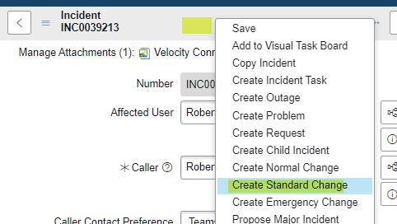

**Then select the Standard template- either Server Reboot or EDI**

**Populate on the change the following fields:**

**Requested by**

**Configuration item**

**Assigned to**

**Update the Short description with the server name**

**Schedule for the change  
(It will be different servers so change the category and configuration items as needed. I simply typed in Beetl and selected what was presented.)**

**Then save, once you have saved the change you now get the option to move it to Schedule (this is the approved state on a change)**

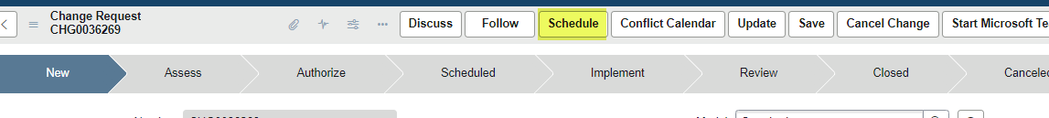

**Once the CHG is created, go back to the INC, reboot the servers and close the INC.**

**Then, go back to the CHG ticket and push it to schedule.**

**Then, change the state to Implement and save.**

**Then, change the state to Review after you have confirmed servers are back online.**

**Then, change the state to closed and provide info in “Closure Information Tab then close the CHG.