BEEF_Prod

Enrollment\Production\EnrollTransCreator\ETC-EnrollTransCreator\877_BEEF_Prod

On mp-abs-sa06

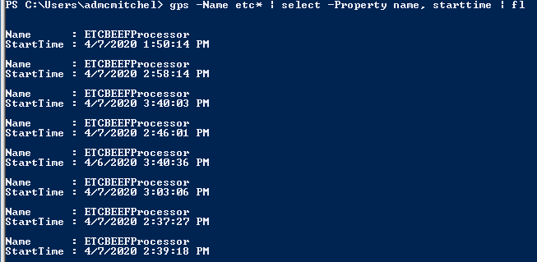

See green is sa05 and sa06 are the purple…

