If file get stuck check here

\\baz-filer01\share\EMFT_FTP\Inbound\GuidingCare\Prod\Letters

In Abat :

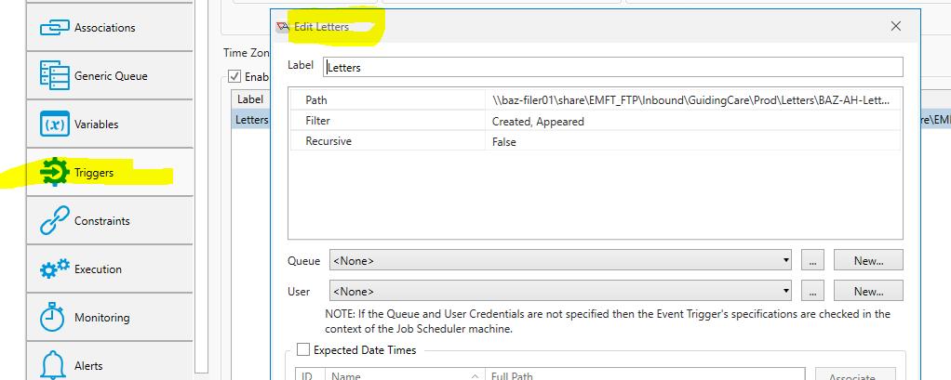

Double click the path and add a space and delete the space

Redrop the files again see it retrigger the job