Missing McKesson File

This is the abat job for McKesson

Mp-abs-a01\IntApps\

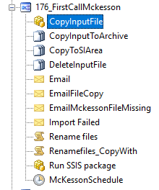

Get an email if the abat job failed….

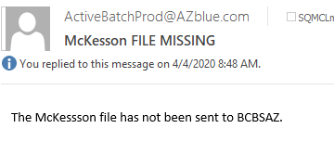

Send email to [pnsapps@changehealthcare.com](mailto:pnsapps@changehealthcare.com) and call 1-833-353-6884

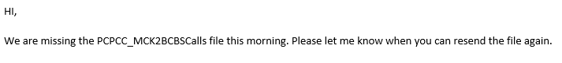

If file is in SI5 might need to replay the file again

