Alert: SSIS Monthly Balance Load - Failure

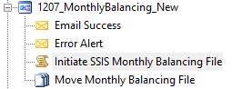

Contact IT Prod Support (Eddie)

File Path:

${dtExecPath} /DTS "\${MSDBInstance}\DocumentTracking\MonthlyBalancingFileLoad" /SET \Package.Variables[User::v_MonthlyBalancingFile].Properties[Value];${@Trigger.FileName} /SET \Package.Variables[User::v_MonthlyBalancingFile_Name].Properties[Value];${@Trigger.FileTitle} /SERVER "${MSDBServer}" /CONNECTION SSIS;"\"Data Source=MP-SQL-CD01I05\SS05P;Initial Catalog=SSIS;Provider=SQLNCLI10.1;Integrated Security=SSPI;\"" /CHECKPOINTING OFF /REPORTING V

Eddie - i think so. but nothing i can fix. Exela is giving me a file that is not formatted correctly, missing a whole column