File/Folder restore using the new AWS version

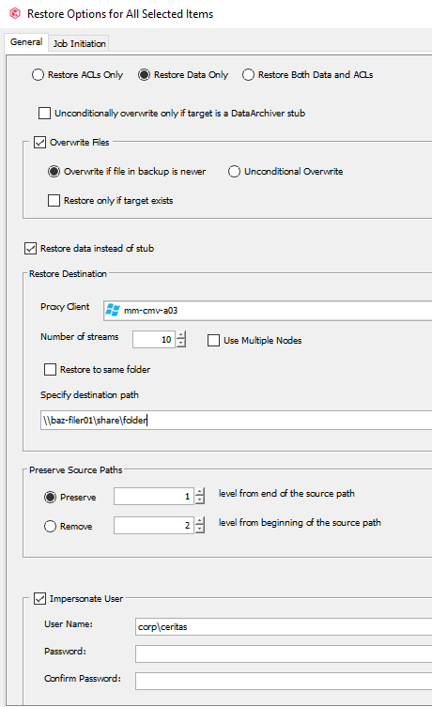

FYI – Linda Paw stuff use mm-ops-a02 X:\Restores file path

Use this only for filer01 or 02 other wise use your adm account….

corp\veritas

V3r1t@5!

Update : use adm account