Restore Non database servers

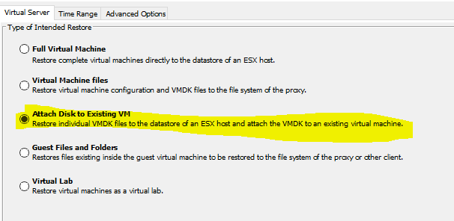

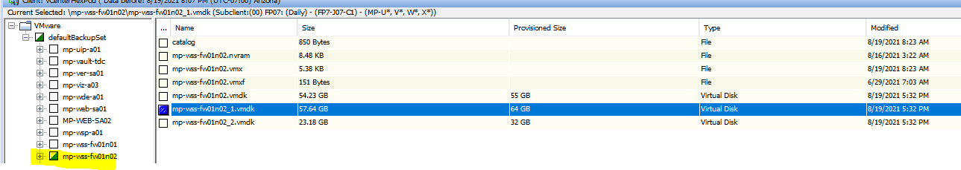

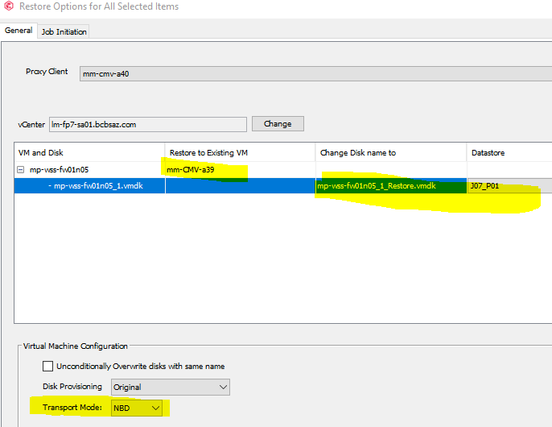

Restore to Existing VM use fp7-j07-c1 (host it on in VCenter)

In Commvault under the control tab

Restore ----

RDP the server you called for

in this case mm-cmv-a39

then goto computer maneagment

then disk management

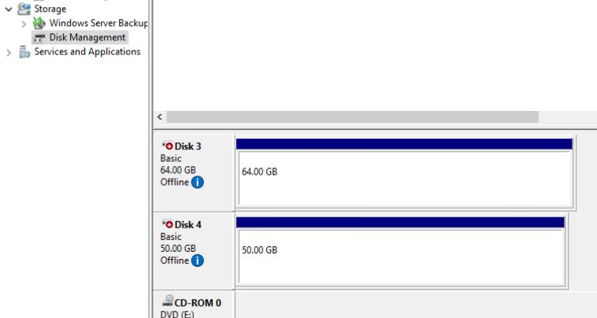

Right click to online

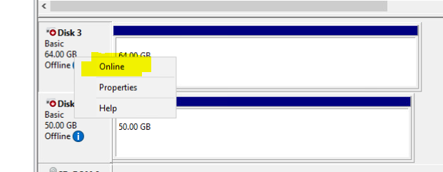

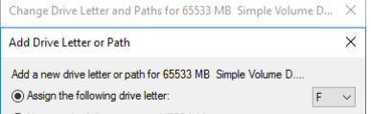

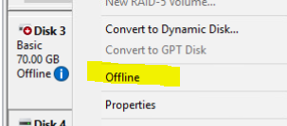

From vCenter

Edit setting

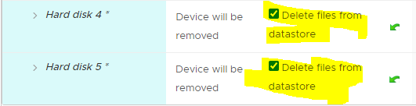

When done make sure to offline the drive and delete…..