In the field pick “action type” then “any of” in value pick 4 items from the drop down menu

Create folder, delete folder, move folder, rename folder

Once you pick those four click add

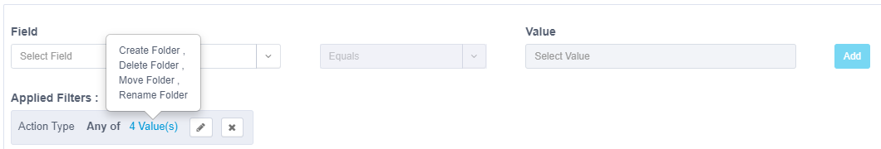

Once you get your filters filled out click the apply to search.

