VM Snapshot

Make sure this is Unchecked the snapshot the virtual memory

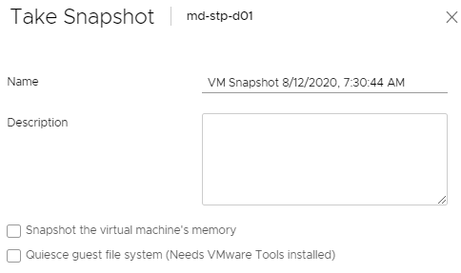

Def:

Yeah, you typically don't want that checked.

It basically tries to capture the exact spot it’s in

If you uncheck it just grabs a snap of the box.  As if it were powered down, and coming up for the first time.

With the box checked it tries to load back in to the exact memory location, so if someone had something running, it would try and capture that in the snap.