[DMD0076514](https://bcbsaz.service-now.com/nav_to.do?uri=%2Fu_demand.do%3Fsys_id%3D8e0cf38f4742b110541fb2a5236d43af%26sysparm_view%3D%26sysparm_domain%3Dnull%26sysparm_domain_scope%3Dnull) - 10-27-23 - Done

DMD0076517 – 10-31-23

DMD0076518 – 11-3-23

per the OE Production deployment window for the portals teams, Rubrik takes backups of the PROD sitecore servers (listed below) at 2300 daily.

This is a request to have those backups disabled on Friday 10/27/23 before 5pm and to be enabled on Saturday 10/28/23 at noon

mp-scr-sd01.aif.bcbsaz.com

\\mp-scr-fw01n01.wdf.bcbsaz.com\

\\mp-scr-fw01n02.wdf.bcbsaz.com\

\\mp-scr-fw01n03.wdf.bcbsaz.com\

vm

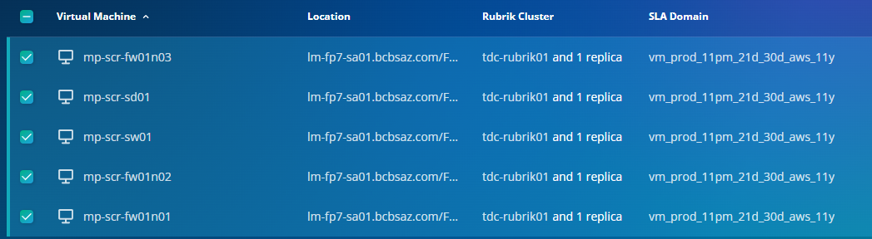

SQL

