**Cycle Payment Dashboard**

Splunk Dashboard for Cycle Payment :

If the dashboard is not balanced, then these are the steps to get it balance.

HRP Panel :

<https://lm-spl-a08.corp.net.bcbsaz.com:8000/en-US/app/splunk_app_db_connect/data_lab#/inputs/edit/mp-hrp-d03_hrp_extract>

User: admin PW: Sp1Unk1tyo!

Azure :

Two location in the storage Account that you can take look for files to be processed for HRP files

SaFISP001 – files drops here first and then

SaFESP001 – files goes to SI5 (Streling Gateway)

Then check on these two folder for the zip files :

\\baz-filer01\SHARE\EMFT_FTP\Inbound\HRP\EOP\Prod\Backup

\\baz-filer01\share\EMFT_FTP\Outbound\RedCard\EOP\Prod

Need to delete a PaymentId to balance the count use this search in splunk :

index=sterling sourcetype="hrp:dbx:bazpdwpr_gg:eop:extract:prd" source=hrp_extract payment_cycle_key!="Child BCBSAZ Individual Supplier Payment Cycle" Payment_Batch_Key=243638 paymentId=4374144 | delete

Make sure the ones that are highlighted Green are in the search……  
once you have the information then use the delete command to delete the paymentId…

D:\CyclePayment

SI files :

Run the SI script :



SI panel update process :

Run the script for Si process



Copy files to this folder :

\\mm-ops-a03\d$\scripts\file_processing\file_processing_eop\processed

Zelis files :

Run the zelis script to get the count….



Update Zelis files :

Run these three files in order :

Copy this files to redcard folder :

On this mm-ops-a03 -

Scheduler :

EOP files :

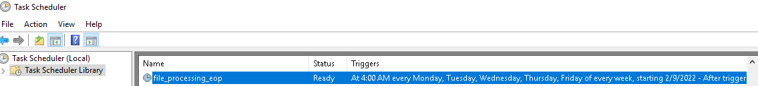

mm-ops-a03 : D:\scripts\file_processing_eop\processed

Zelis files

mm-ops-a03 - D:\scrpts\file_processing\file_processing_redcard\processed\

D:\CyclePayment\EOPSI\

D}\CyclePayment\EOPRead

D:\CyclePayment\ZelisCount\

Zelis files to be unzip :::::::: ---------

D:\Scripts\redcard\eop\working

