Check Doc1 Group Bill Model Office

Open putty or other means to AIX1

Once you log in go to this folder “scripts”

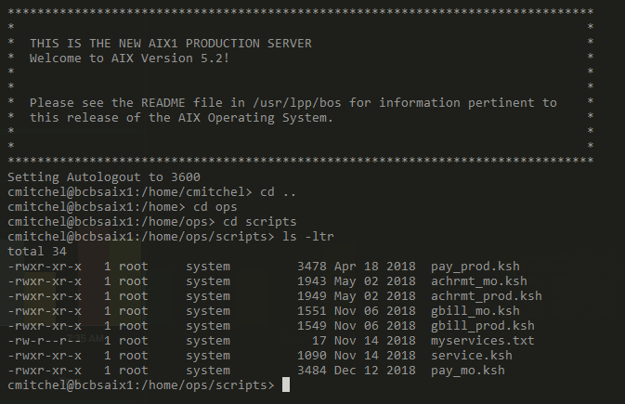

Run this command: ./achrmt_mo.ksh



Should see four files from the same date (ex: 4-3-20)

