BCBSImag

u - root

p - Imag0ebs

enter twice

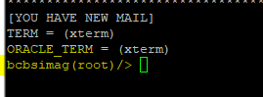

su - fnsw

enter twice

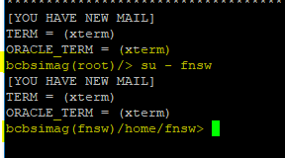

cd tmp

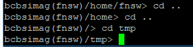

mkdir of the (ticket nu (Taskxxxxxxx)

cd to created ticket

vi create a txt file

esc i

shift :

wq

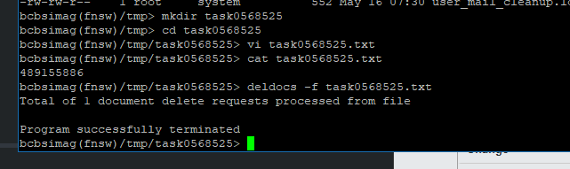

To del crtl h – in cse u make a mistake