Filenet Document Delete (*Delete Documents from FileNet Task Tickets*)

* Single Doc ID:

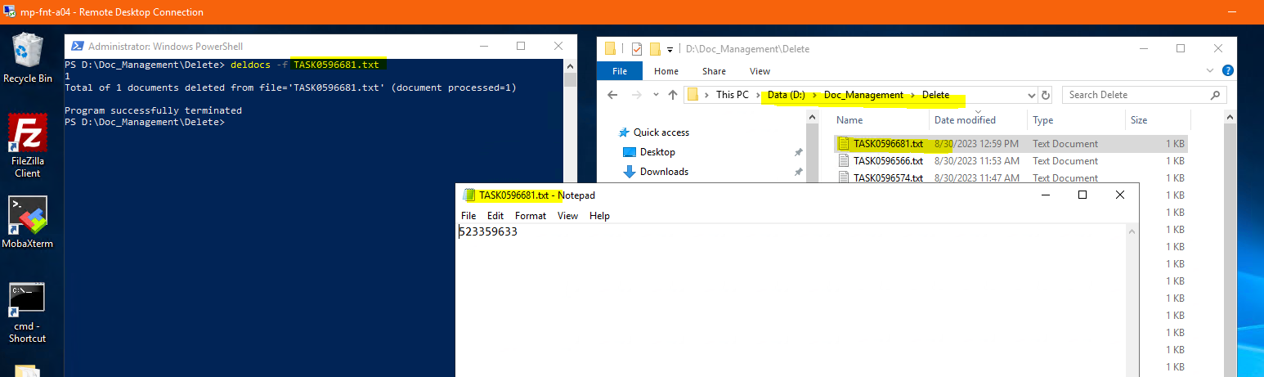

* Multiple Doc ID:

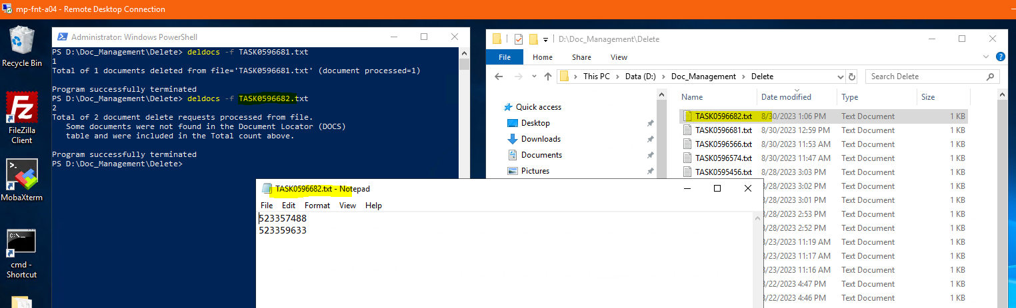

Log into MP-FNT-A04

Log in as U: corp\svc_fnsw, P: Ezz9YfT3dP3w

* Open PowerShell session. Do not use PowerShell ISE
  + Change directory to D:\Doc_Management\Delete
* Open Windows Explorer and go to D:\Doc_Management\Delete
* Right click, New Text Document
  + Copy and paste Doc IDs
  + List all Doc IDs from the Task
  + Name the Notepad.txt file the same number as the Task
    - Example: CTASK0596566.txt
  + Save
* Use command: deldocs –f ‘TaskNumber.txt’
  + Enter
  + Program Successfully Terminated – *Done*