Pinnacle Admin

**Path to PinnacleAdmin for Production, Model Office and Dev:** \\baz-filer01\Share\MSART03\IS\PinnacleAdmin

Overview

Pinnacle Admin is a tool used to create Pinnacle Roles and Mnemonics. The roles define the access one has to specific mnemonics. This access is used in Clipboard/FileNet/Image Retriever and FindIDM and allows a person to pull up or upload a document to a specific mnemonic.

Example:

Role 106 (Claims)

Allows a person to view or upload a document using any of the Claim mnemonics such as:

CL0002 – Original Correspondence

CL0006 – Dental

CL0012 – Provider Return Letter

And many, many more.

The Process

The process to create a new role or mnemonic (or alter one) first takes place in the DEV environment at I:\BSD\Pinnacle Admin\DEV. The role/mnemonic is defined and rights are added on dictating what role/mnemonic can have access to the role/mnemonic. Rights are 0 = No access, 1 = Read Only and anything over 2 is Read/Write.

Once created in DEV, that change needs to be promoted to Model Office. Pinnacle Admin Model Office is located at S:\BSD\PinnacleAdmin\Windows 7\ModelOffice\PinnacleAdmin. The screen prints below show the process to promote an item from DEV to Model Office.

Open Pinnacle Admin Model Office. The Main Menu displays:

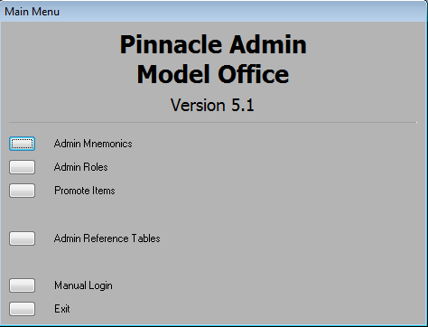

To promote either a Role or a Mnemonic, click on “Promote Items.” The Promotes screen displays:

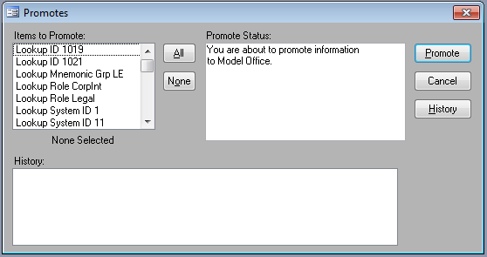

Select a role or mnemonic to promote from the “Items to Promote” list. You can select multiple items by using Ctrl+click or Shift+click.

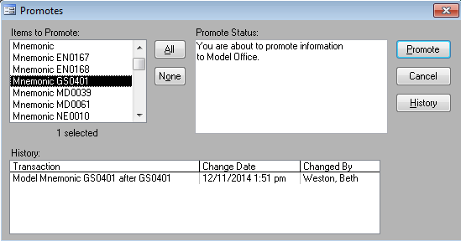

Click “Promote” to promote the item from DEV to Model Office:

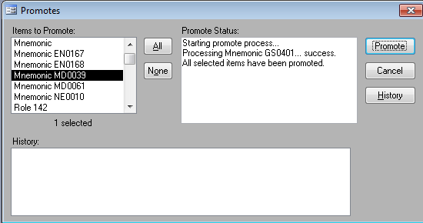

The role/mnemonic disappears from the “Items to Promote” list and the “Promote Status” box indicates that the promoting process has been a success.

At this point, the QA Analyst would test the new role/mnemonic doing QAT and then UAT. Once approved with UAT, the QA Analyst would schedule the move to Production using a Serving Blue ticket/change control process. It is at that point that Operations would need to participate in the Release call and promote the item(s) from Model Office to Prod using the same steps as above. The only difference would be that the promotion would be in Production, not Model Office. I do not have Production Pinnacle Admin so am unable to show this process exactly but it follows the process above for Model Office.