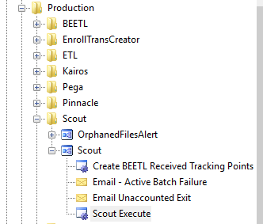

Check this process job…. To many kill them all…..

