**GBILL Model Office**

-File is going through SI5 – Stage / QA.

-Login <http://mp-si0-a01:11600/filegateway/home.do#login>

-Search for file D3IGBILL

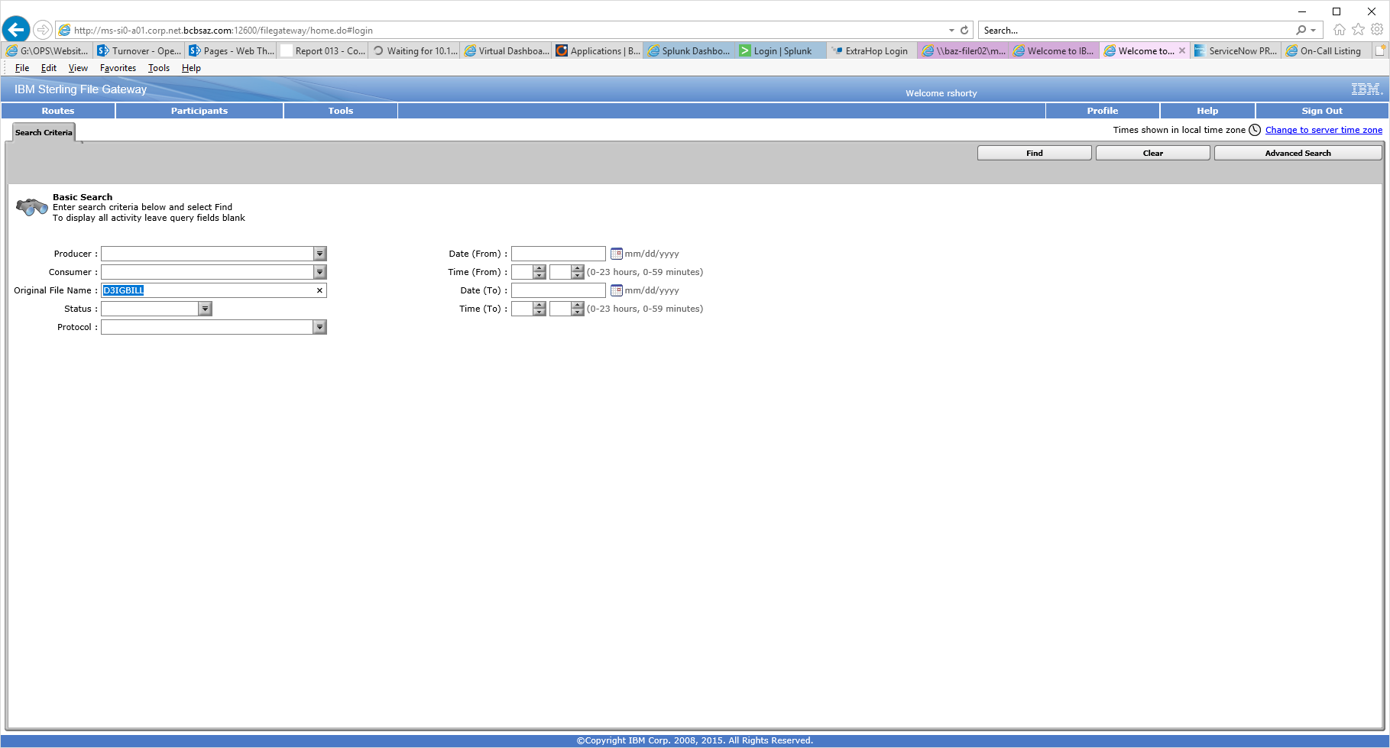

-Click on **find**. Should see below.

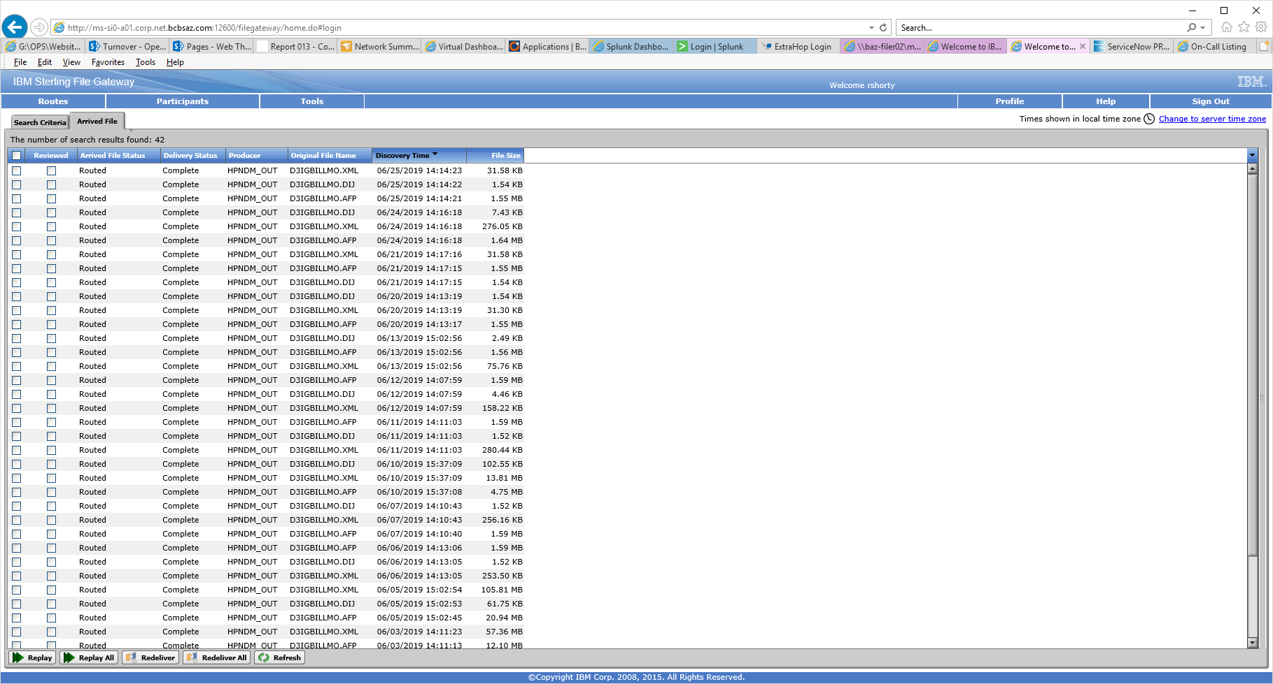

-File should be in by 2:30pm.

-If no file by 3:30p, make a note of it.

**Note:** Any issue, send e-mail to SI5 Team, IT Prod Support and CC: Operations

If issue with SI5 Application: Andrea Browning and Hung Nguyen

If issue with SI5 Servers: Bill Eblin