**GBILL Production**

Effect 2-5-19

No longer through AIX1!

-Link to Sterling Intergrator 5 (SI5):

\\baz-filer02\MICRO\OPS\Documentation\5010\SI5\SI_web_dashboard\SterlingIntegrator5.htm

Login: your windows credential

-GBILL Production send through SI by 8:30pm. (Example below)

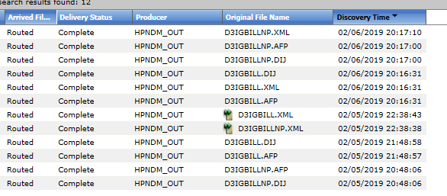

-if no GBILL by 9:30pm... I N V E S T I G A T E!!

-0ld Notes on how to resolve GBILL_Prod issue:

G:\OPS\Documentation\1_Operations Monitoring\DOC1\zOld_GBILL_Prod.docx

-If Operation is unsuccessful with initial resolution, notify IT Prod Support

-E-mail notification will be sent to: IT Prod Support, Andrea Browning and CC: Operations