Payment MO

Six Payment files from Aix1 to DXC

BSDtoAIX_PREMPAY_GVP_mod

BSDtoAIX_SUBSCRIBER_ACH_mod

BSDtoAIX_MOBILE_PAYMENT_CADA_mod

BSDtoAIX_SUBSCRIBER_ACH_mod

BSDtoAIX_MOBILE_PAYMENT_IA_mod

BSDtoAIX_PREMPAY_WEB_mod

File location:

\\corp\dfs\abq-bsd\851_Payment_Processor\Output\20200404MobCADA.txt

\\corp\dfs\abq-bsd\851_Payment_Processor\Output\20200404MobileIA.txt

This is where the file get processed in Abat.. If job failed for some reason.. research the issue and then retrigger the job again.

In Abat MU-ABS-A01 – IntApps\

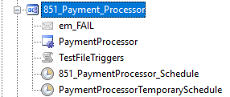

Log in to AIX1

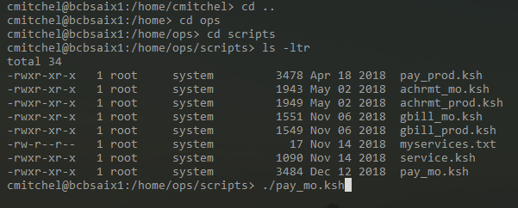

What it should like if successful…. If file is missing then…….

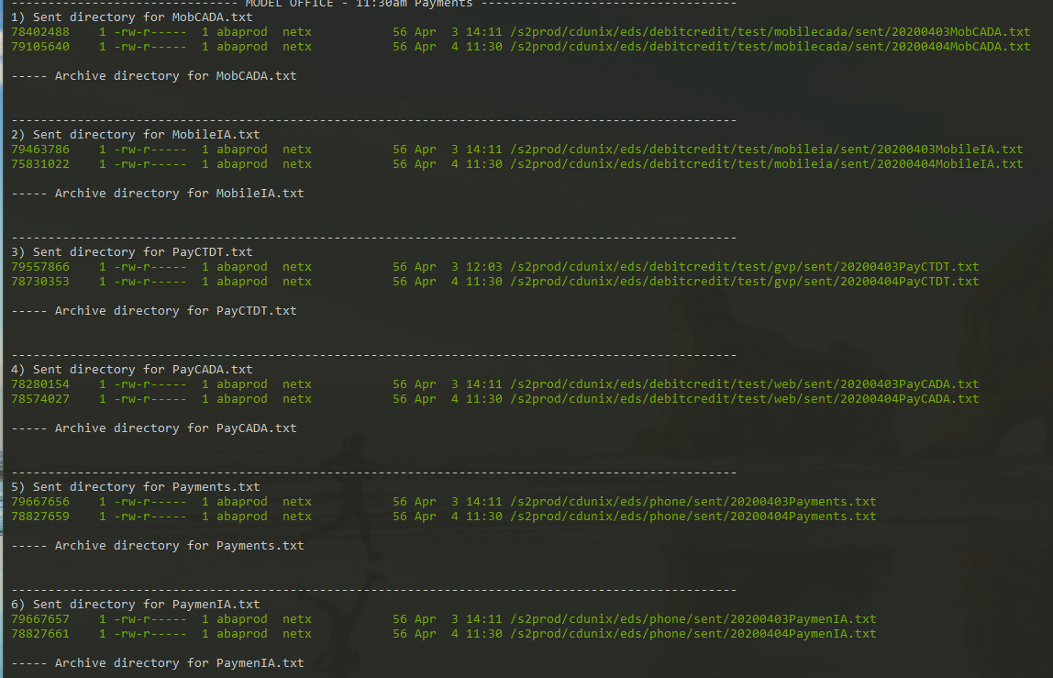

This is how you resend the payment file again….