**Model Office Payment issue at 11:30AM**

What was done regarding resending missing payment. Feel free to make any changes.

*Active Batch: 851_Payment_Processor has successful status (false alert)

*log into bcbsaix1

            -Changed to **root** credentials

            -Changed credentials again to **su - abaprod**

*Checked directory: /s2prod/cdunix/eds/debitcredit/prod/mobilecada/sent

            -no file for March 20, 2017 (which means HP did not receive it)

*Also checked directory: /s2prod/cdunix/eds/debitcredit/prod/mobilecada/archive/**20170320MobCADA.txt**

*typed **cat 20170320MobCADA.txt**

           -verify number of payments in the file – was all good

            -verify no unusual characters under names – was all good

*Moved file from “archive” folder to “mobilecada” folder (if you’re already in the archive folder)

            -type move command **mv  20170320MobCADA.txt  /s2prod/cdunix/eds/debitcredit/prod/mobilecada**

*run NDM job to send the missing files

           -in directory /s2prod/cdunix/eds/debitcredit/prod/mobilecada

-type run command **./oo_prempay_mobcada_push.ksh**

   -error I saw when running script (looping)

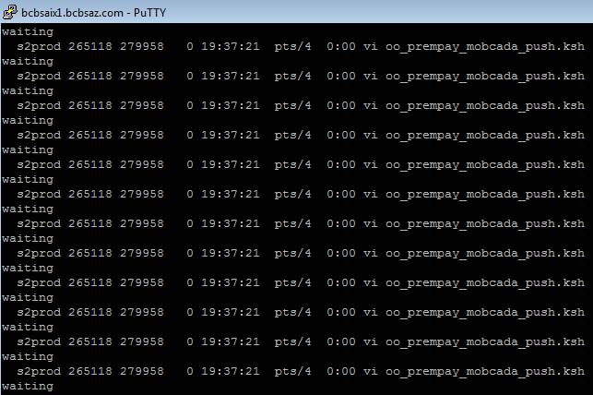

                -Type command **ps -ef | grep oo_prempay_mobcada_push.ksh** (it does a process check and if it sees another instance of the process running it loops)

**-**Displayed processes were killed



                -retyped run command **./oo_prempay_mobcada_push.ksh** (in the case job was successful)

*After it successfully runs the script, reply to HP’s e-mail to confirm payment has been received (in the case HP did received payment)

*Done!