**New Process for ACH RMT Model Office**

-No more e-mails at 9:30am and at 11:30am

-New process is through Active Batch Version 10

-Launch AB Version 10 (new process under mu-abs-a01)

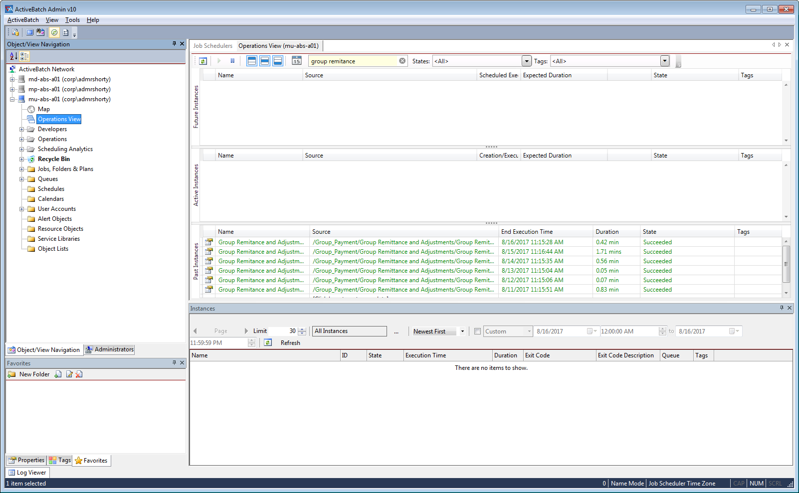

Next Page….

-Active Batch job:

-Group_Payment -> Group Remittance and Adjustments -> Group Remitance and Adjustment Agent

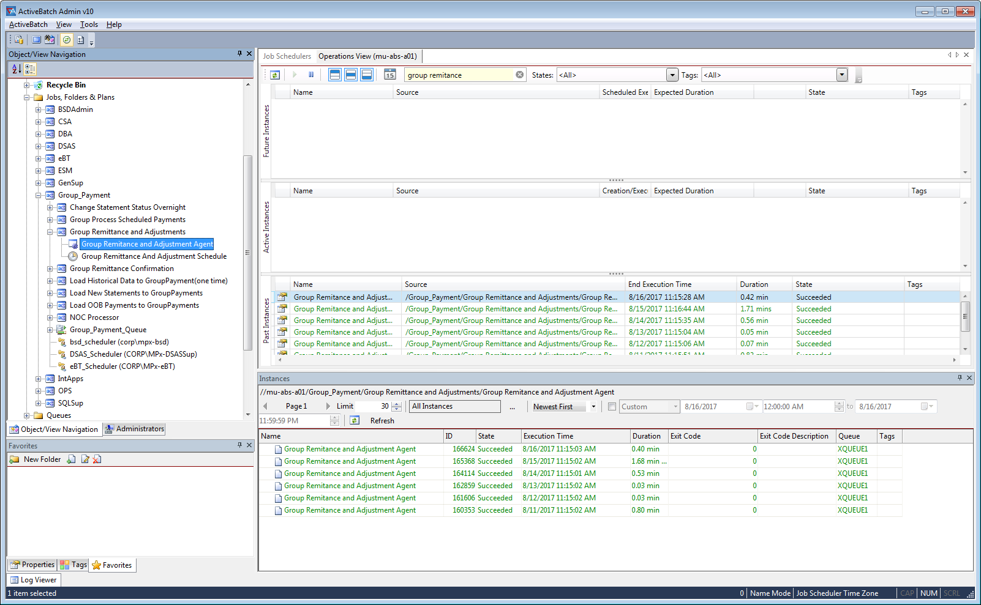

-Job runs at 11:15am



-if job fails, notify Irene Arustamov

Next Page….

Note: Also check in SI5 – QA/STAGE if 2DXC files failed

<http://ms-si0-sa01.corp.net.bcbsaz.com:12600/filegateway/home.do#route>

