**Getting Started:**

**Overview/Exec Dashboard**

[Exec Prototype : Customer Facing Systems and Key Dependencies - Blue Cross Blue Shield of Arizona: azblue - Dynatrace](https://jjp98670.live.dynatrace.com/#dashboard;gtf=-2h;gf=all;id=856487a1-ca56-4934-89e2-015248ed00cd)

The basic breakdown is a follows:

I = The basic public facing portal services

II = The various collection of synthetic tests “validating” the portals beyond what the real-user data is doing. This a mixed of authenticated and unauthenticated tests

III = These are the core back-end EDI systems, including EDIFECS

IV = Dynamics and DocManagment (Image Retriever)

V = Very high level over view of Vcenters

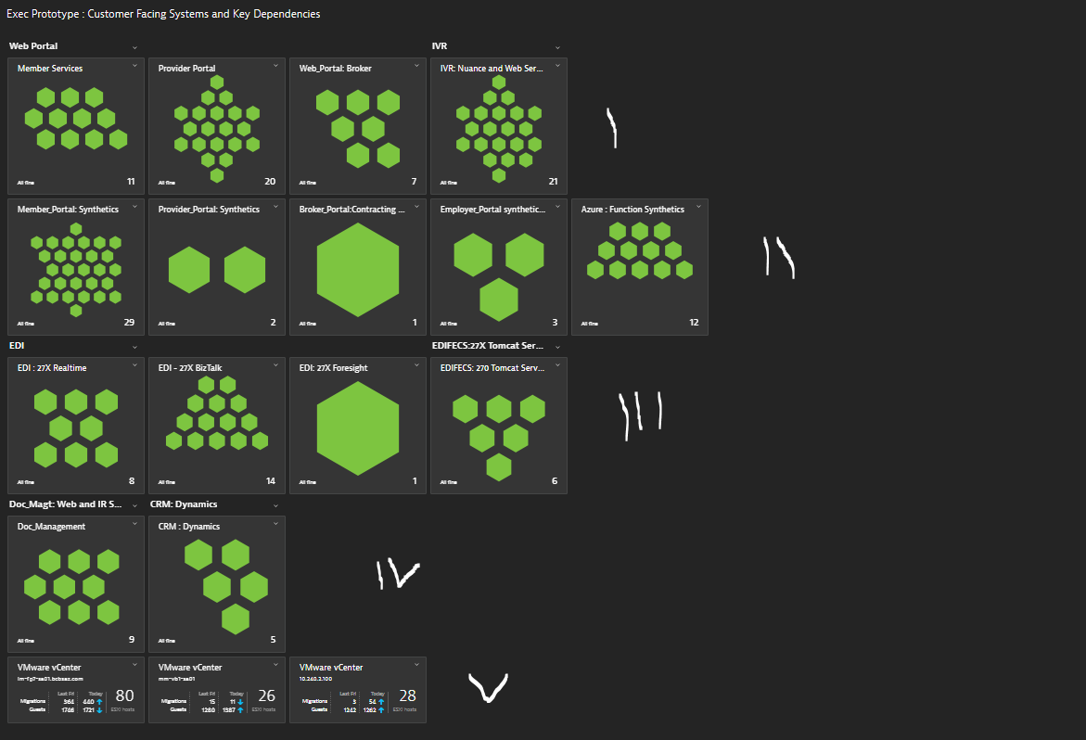

**Problem Window:**

* **In the upper right-hand side is a count of “open” problems. There will be problems which don’t always percolate up to the dashboards. That’s normal and okay.**
* **But if it’s “red” in the dashboard it will be in the problem count.**

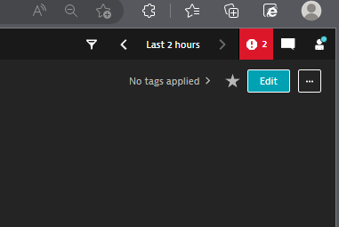

[HRP Database(S) - MP-HRP-D04 = Member Portal Servces : MP-HRP-D05 = Member Portal Login and Billing, Autopay, Invoices : MP-MBC-D01 = Mirth Services | Splunk 8.2.4 (bcbsaz.com)](https://lm-spl-a07.corp.net.bcbsaz.com:8000/en-US/app/bcbsaz_ta_operations/hrp_d04_database?form.Time_TOK.earliest=-24h%40h&form.Time_TOK.latest=now&form.SERVER_TOK=MP-HRP-D05)

**Overview:**

* The most important aspect of using Dynatrace effectively is to understand the vocabulary employed by the tool and being able apply those concepts to BCBSAZ’s infrastructure and application layer.
* To date the emphasis has been on logically organizing BCBSAZ’s infrastructure and collecting data
* **Understand the context of infrastructure menu**

1. Enterprise Application
2. Application
3. Process
4. Service
5. Host Group
6. Management Zone
7. Dimension

* Within the **“Infrastructure”** menu in the Dynatrace GUI there is a **“Hosts”** option

1. All directly monitored hosts (VMs, physical servers, any machine capable of running a OneAgent) can be found here.
2. Each monitored host is bound to a collection of “properties” and “tags”. These give context to the hosts allowing people to quickly discern the role the server plays within the larger framework of BCBSAZ applications and services (see above).
3. This will be important to note as you search via management zones, dashboards, metrics, data explorer and for the purposes of this document the MDA (multi-dimensional analysis).

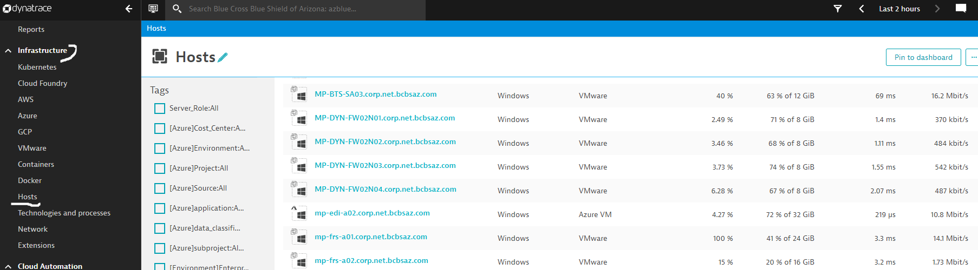

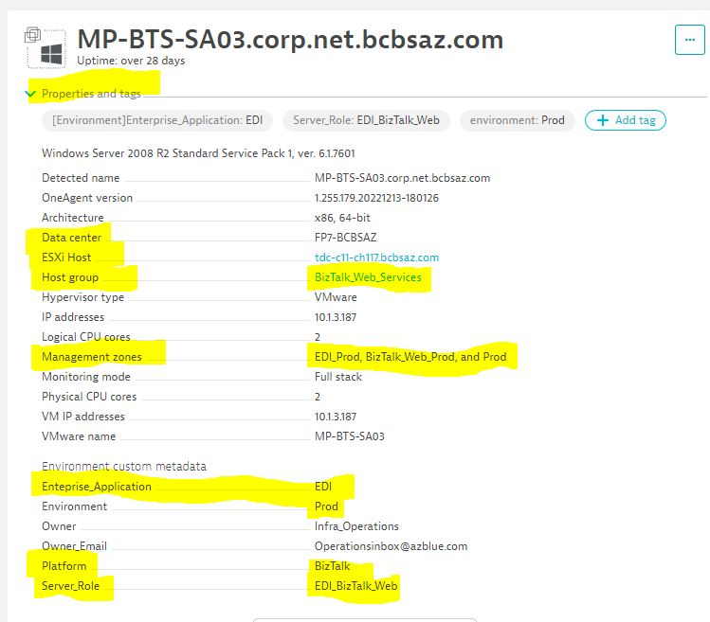

* The organization and filtering of the “Dashboards” (under “**Observe and explore**”) , **Metrics** and the “**Multidimensional analysis**” pages are in large measure organized based on these tag values.

**Example Metrics Page:**

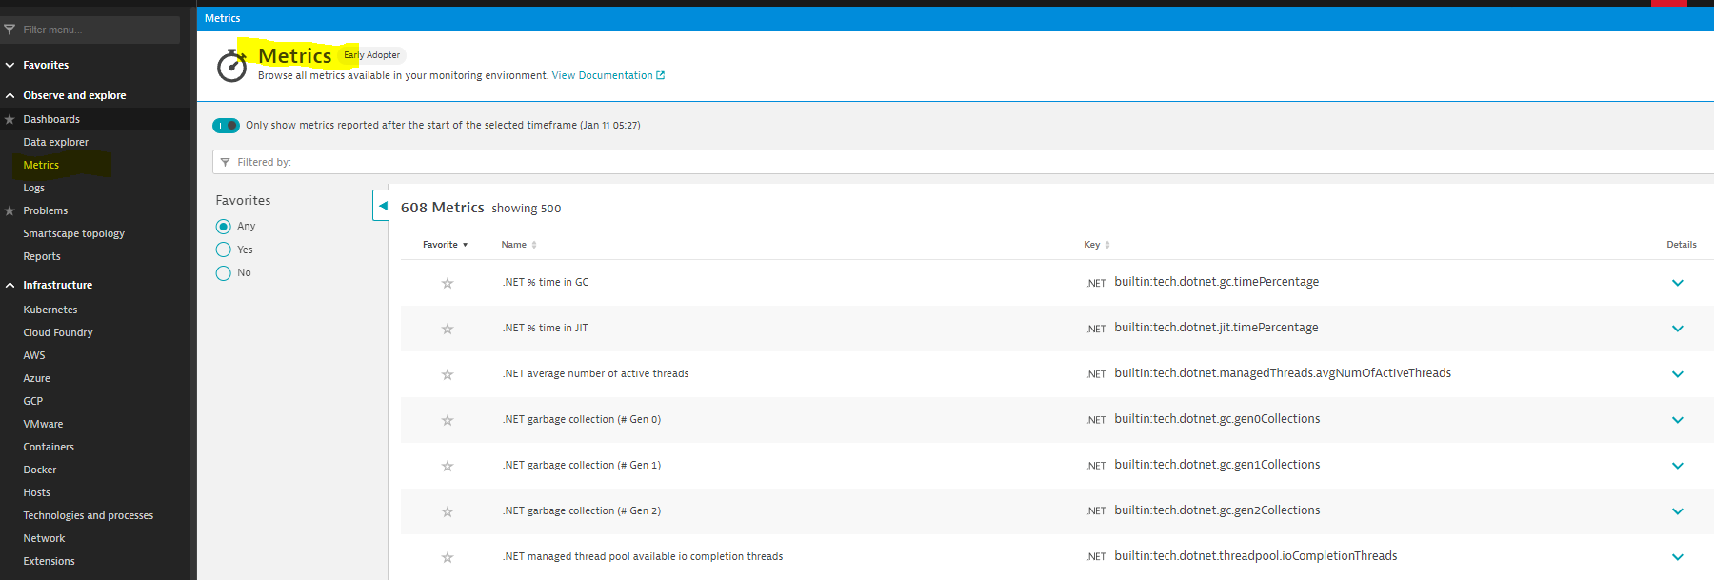

**Each Metric will easily provide basic “meta data” information**

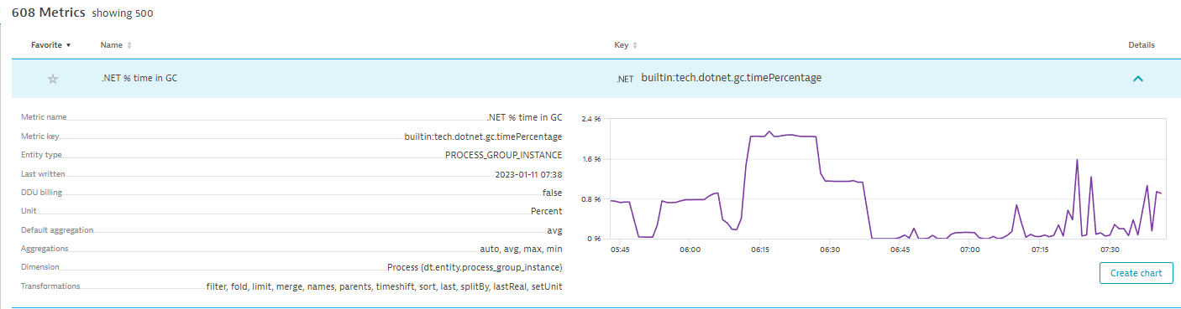

**Executive Overview Dashboard:**

[Exec Prototype : Customer Facing Systems and Key Dependencies - Blue Cross Blue Shield of Arizona: azblue - Dynatrace](https://jjp98670.live.dynatrace.com/#dashboard;gtf=-2h;gf=all;id=856487a1-ca56-4934-89e2-015248ed00cd)

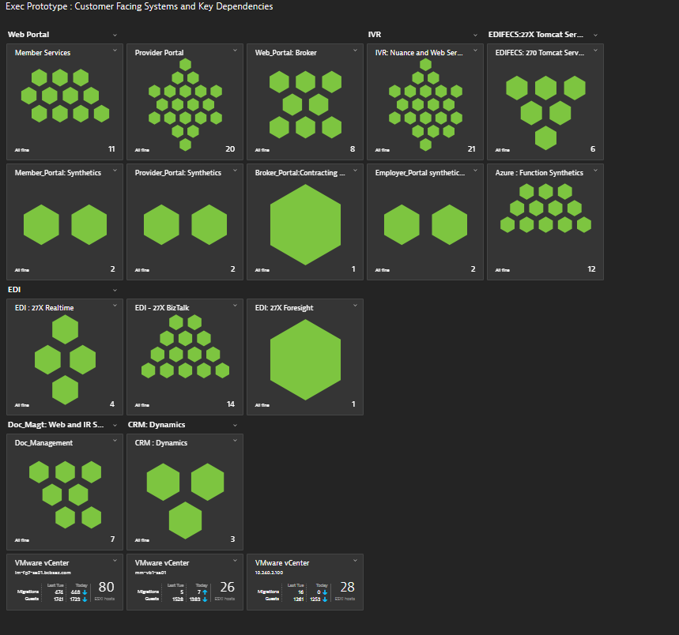

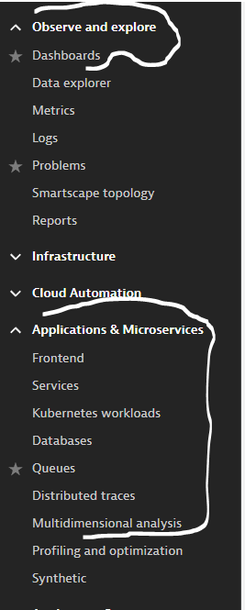

**Sample Problem Drill Down:**

* Tracking and correlating “problems” starts in **“observe and explore”** menu

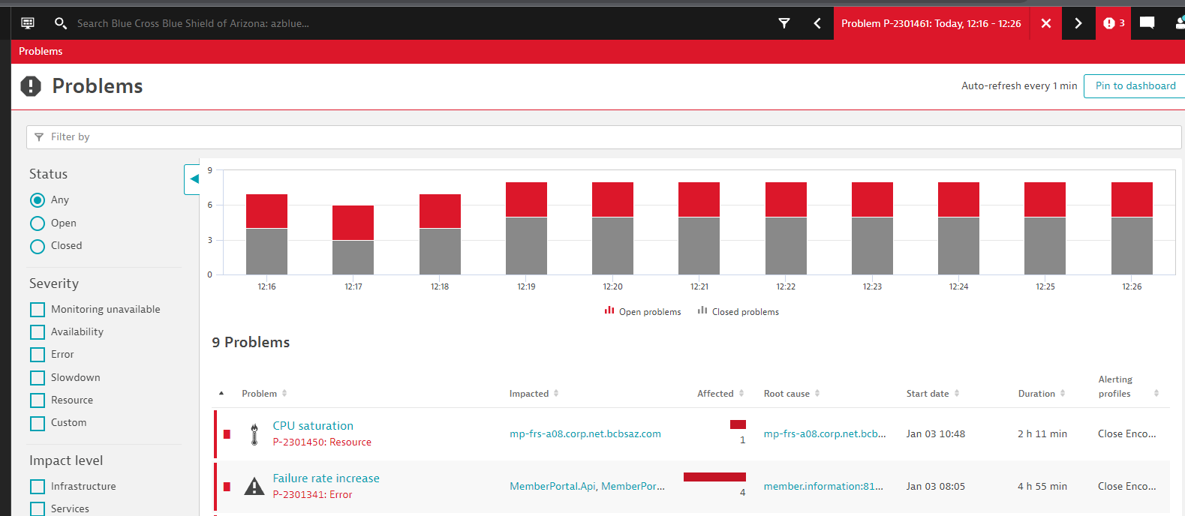

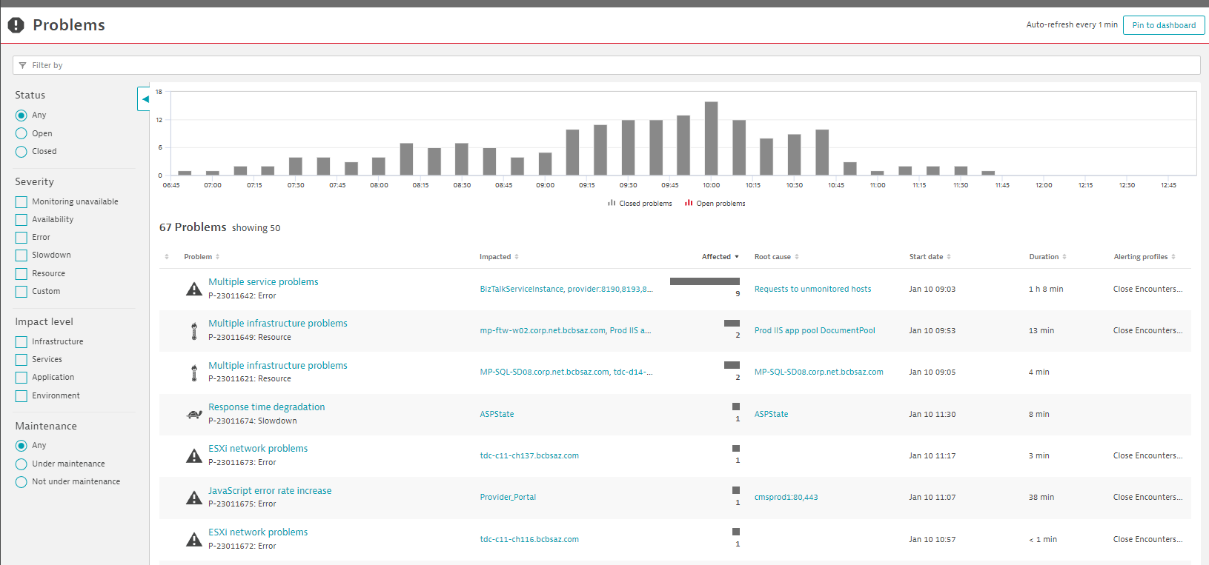

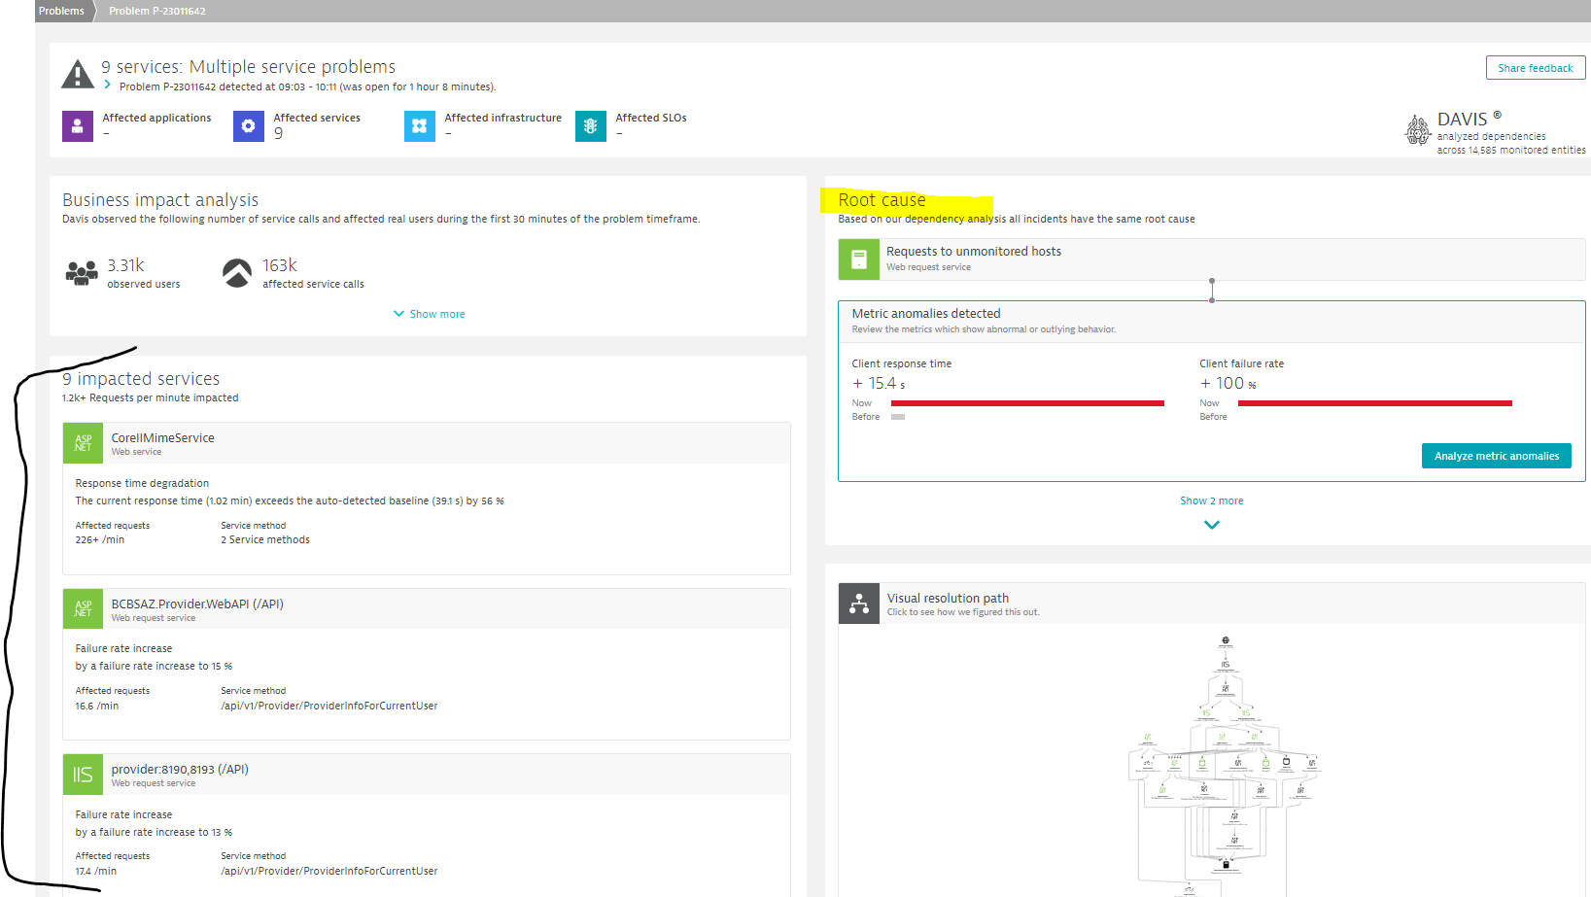

**Overview Dashboard:**

[Exec Prototype : Customer Facing Systems and Key Dependencies - Blue Cross Blue Shield of Arizona: azblue - Dynatrace](https://jjp98670.live.dynatrace.com/#dashboard;gtf=-2h;gf=all;id=856487a1-ca56-4934-89e2-015248ed00cd)

* The idea is to provide a purposeful and easy “visual” to call out issues in BCBSAZ various “application” environments as well as back-end support systems.
* Each “hex” represents a key service tied to an application or enterprise application. (bear in mind the definition of application in the Dynatrace world).
* If a service is not performing it will show “red” and then link back to the problem.

**Example:**



