BX Close out

Once log in get to this home page

Click on the BX Cog_Report

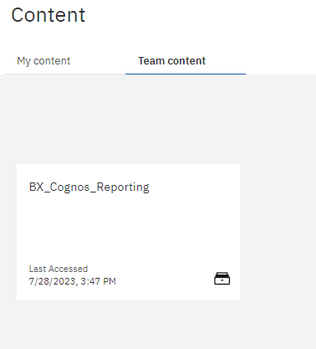

Then goto to the select date range

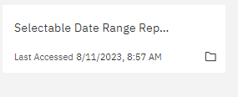

Goto the report 013 control plan

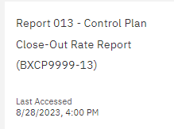

Highlight all the plan code and click finished

