Biztalk

At the command prompt, type net stop WAS and press ENTER; type Y and then press ENTER to stop W3SVC as well.

To start the web server, type net start W3SVC and press ENTER to start both WAS and W3SVC.

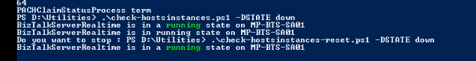

# invoke-command -computername "TARGET-HOST" -scriptblock {iisreset /STOP}

# invoke-command -computername "TARGET-HOST" -scriptblock {iisreset /START}

# invoke-command -computername "TARGET-HOST" -scriptblock {iisreset /RESTART}

Errors :

MessageRefCountLog1

MessageRefCountLog2

MessageRefCountLogTotals

MessageZeroSum