Foresight D Drive is full

Goto the logs folder see screen shot of file path:

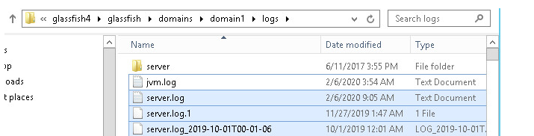

Delete the server.log from past month for A02, A04 and A06 (Glassfish)