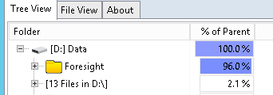

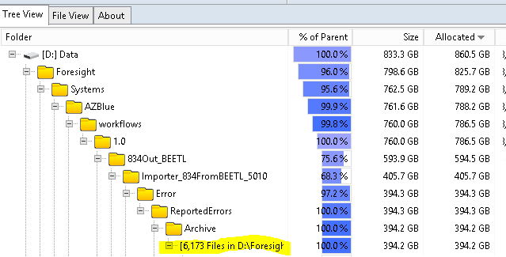

D:\Foresight\Systems\AZBlue\workflows\1.0\834Out_BEETL\Importer_834FromBEETL_5010\Error\ReportedErrors\Archive

Files from 2020….

Beetl is own by team Best…