Redrop 835 files

Biztalk server SA03

Field name: 835_MV_Retry_Recieved_Location this should be disable….

URI = SS02\835\Retry\MV\*.x12

Check the received location

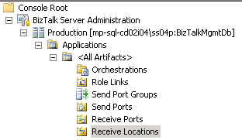

835_MV_Retry_Recieved_Location (disable)

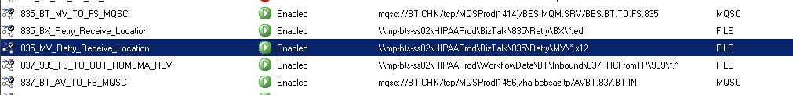

Source = MP-FRS-A07 (Email from IT Prod)



Destination = MP-BTS-SS02 (Drop Location)



[‎4/‎17/‎2020 1:31 PM]  Mitchell, Chris:

HI Rob  
Have a ticket DMDTSK0009396 from Linda..  
These are the 835 files. I know there is a new way to redrop these files..  
make sure i under that this process...  
  
log into biztalk sa03 and went to the recv location 835_MV_Retry_Recieved-Location and enable it..  
  
redrop it in this folder \\mp-bts-ss02\HIPAAPROD\Biztalk\835\Retry\MV\..  
  
 is this right so far?

[‎4/‎17/‎2020 1:31 PM]  Hall, Robert:

1 moment

[‎4/‎17/‎2020 1:31 PM]  Mitchell, Chris:

ok

[‎4/‎17/‎2020 1:52 PM]  Mitchell, Chris:

HI.... can I drop all the files at once or i have to do it in small segment.. there is a total of 290 files to be redrop

[‎4/‎17/‎2020 1:53 PM]  Hall, Robert:

okay of my call...

can I call you you?

[‎4/‎17/‎2020 1:53 PM]  Mitchell, Chris:

yes

Connected to Hall, Robert (robert.hall@azblue.com).

Call with Hall, Robert (robert.hall@azblue.com) has ended. 9 minutes