**How to fix TIUtility log errors:**

Upon receiving an alert for a TIUtility error log perform these steps to resolve:

Log into MP-FRS-A01 using the frsprdsvc account.  
 Open the Task Scheduler and search the TIUtilities tasks for the mentioned task failed in the   
 email (usually the SummNonMultiSingTransByDayWkMnth is culprit)  
 Run the task and email saying you performed the basic first step

Wait an hour and see if the email comes again. If so, follow the next steps.

1. Follow the procedures in G:\OPS\Documentation\5010\Foresight
2. Open up work file How to fix TIUtility log errors.docx
3. Check the most recent log to see if it is still has this error “***The process is already in progress or abnormally terminated***”. If it does proceed to the next steps.
4. *Look at D:\Foresight\Instream\Bin\$dir.ini for whichever server presented the alert and open the file with Notepad of Wordpad to view the text. (Scroll towards the bottom, it will be for TIPortal)*

* *Each Foresight server points to a different SQL server for TI portal so it is important to view this file in the correct server*

1. *Make note of the server name and credentials for AZTIPortal because you will need those in the next step.*
2. *Log into* ***MD-FRS-A03*** *using frststsvc credentials and launch Microsoft SQL Server Management Studio. This is where you will input the*
3. *SQL server name and credentials acquired from the previous step.*
4. *When logging into SqlServer, Login username should be TIPRODUser, PW: (Eph8xJs*

*Example of login*

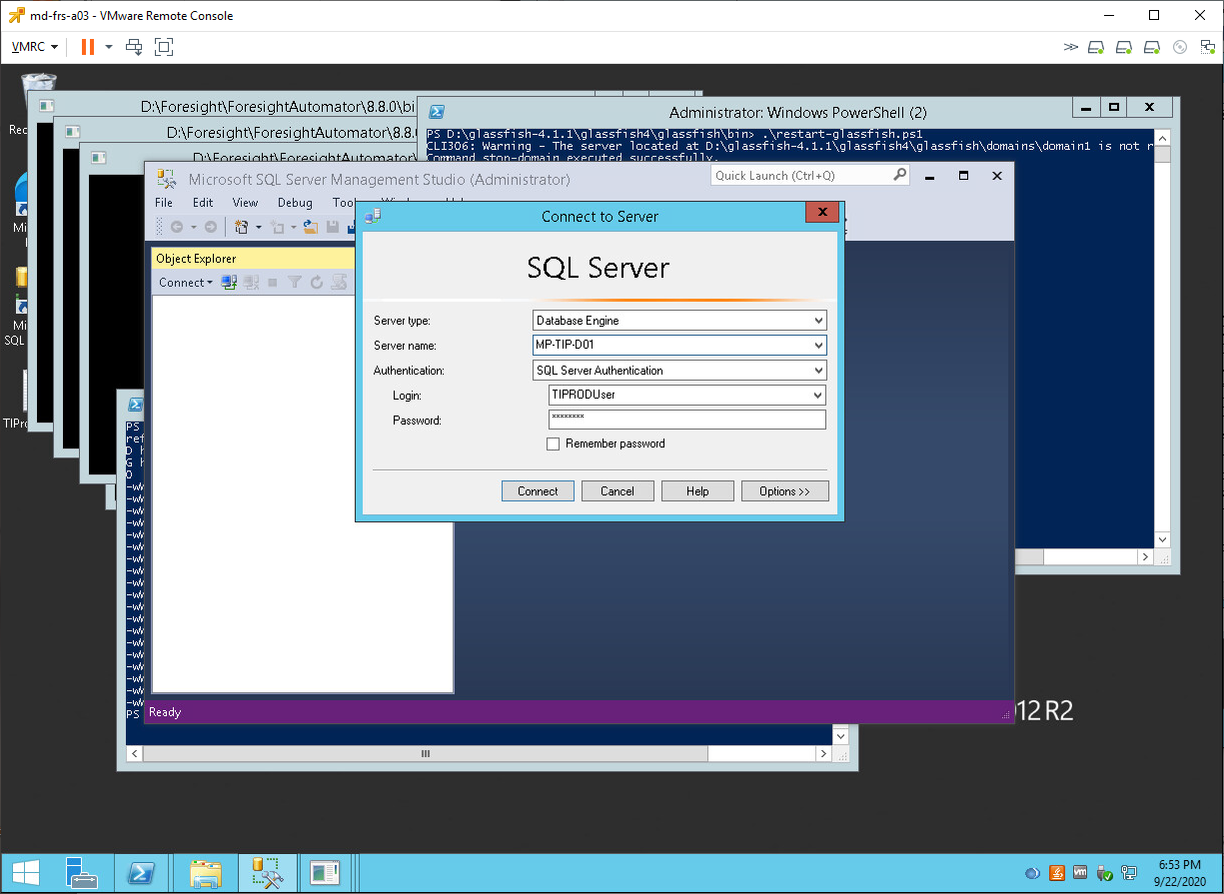

1. *Expand the ‘Databases’ section on the left, right click on the TIPROD database in the pane, and select ‘New Query’. Use the following query statement:*

*Update TransmissionProcess Set ProcessStatusCodeID = 4 Where ProcessStatusCodeID = 3*

*AND (PROCESSID = 1 OR PROCESSID = 2 OR PROCESSID = 3 OR PROCESSID = 5)*

1. *Click “Execute” and wait for the message indicating the query has run successfully.*
2. *DO NOT SAVE THE QUERY THAT WAS COPIED AND PASTED, CLOSE OUT AND YOU ARE DONE!!*
3. *Go back to the Production Foresight server that presented the alert and re-run the TI Utility* ***scheduled task (usually, mp-frs-a01). Make sure this matches the log file presented in the email before running.***
4. Check the TI Utility log to verify it is running properly
   1. D:\Foresight\Systems\AZBlue\TIUtilitiesLogs

For real time TiPortal  
Server mp-tip-d03  
User – TIProdUser

PW – (Eph8xJs