Screen shot of the old transaction

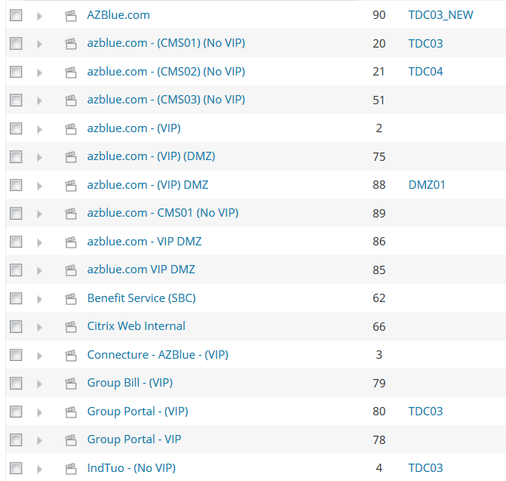

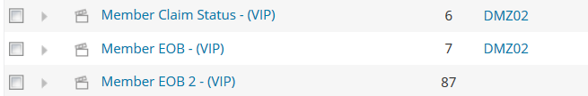

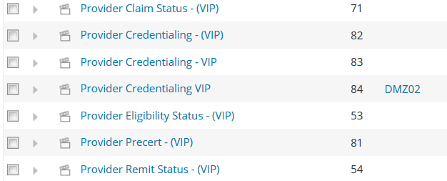

New WPM Servers

VPCW10PNDA011 TDC01_New IP: 10.1.62.0

VPCW10PNDA012 TDC02_New IP: 10.1.59.24

VPCW10PNDA013 TDC03_New IP: 10.1.61.243

VPCW10PNDA010 TDC04_New IP: 10.1.56.203

New servers for wpm

