CMDer

Log-in

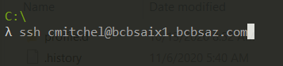

RDP

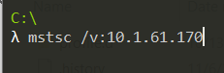

Reset Map Drives

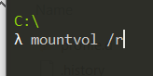

|  |  |  |
| --- | --- | --- |
| **ISP Provider** | **IP Address** | **Cable Color** |
| Cox | 10.0.30.109 | Yellow |
| Century Link | 10.0.40.50 | Light Blue |

To What IP using  
Open browser and type in search  
"What is my IP"