Sell PTO Back in Work Day

My notes

**From:** Shorty, Rodney <[Rodney.Shorty@azblue.com](mailto:Rodney.Shorty@azblue.com)>   
**Sent:** Monday, January 18, 2021 4:22 PM  
**To:** Shorty, Rodney <[Rodney.Shorty@azblue.com](mailto:Rodney.Shorty@azblue.com)>  
**Subject:** RE: PTO Reminder ***Notes

Click on ‘Request Absence’

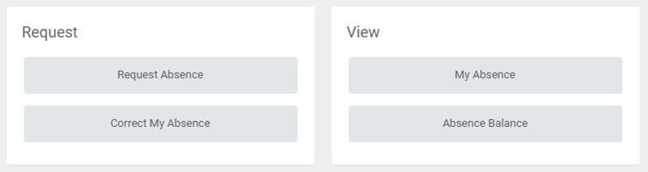

Select a date



Then click on 1-Day – Request Absense



Select PTO Sell Back

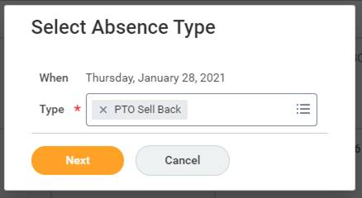

Eneter number of hours

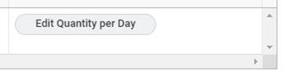

Enter 40

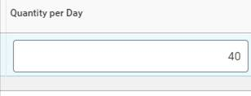

You will see 40

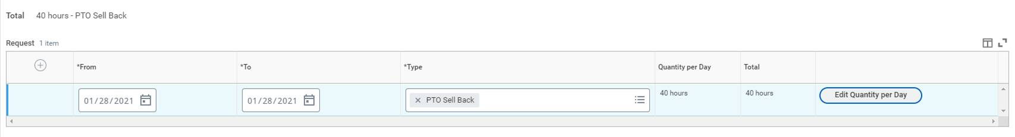

Optional for comment ‘First request, selling back 40 hours of my PTO on payday 1-28-21’

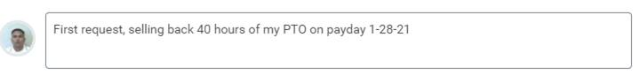

Click on submit

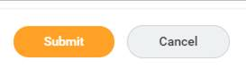

Will state “the this completed successfully”

Then you’ll see this on your calendar/payday.

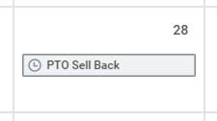

**From:** Sommerfield, Pam <[Pam.Sommerfield@azblue.com](mailto:Pam.Sommerfield@azblue.com)>   
**Sent:** Monday, January 11, 2021 10:47 AM  
**To:** Sommerfield, Pam <[Pam.Sommerfield@azblue.com](mailto:Pam.Sommerfield@azblue.com)>  
**Subject:** PTO Reminder

**“You have been blind-copied on this e-mail for confidentiality purposes”**

**This is a safe e-mail sent to you by Human Resources**

Hi,

I  want to let you know that you have reached, or will soon reach, your PTO accrual maximum. Please refer to the [PTO Accrual Policy](https://planetblue.azblue.com/EmployeeCentral/Human-Resources/employee-guide/Pages/Working%20Hours.aspx#PTO) which covers important information including your maximum accrual hours.

We know it’s tough to take a vacation during this challenging time, but it is still important to take time away from work to relax and recharge. Taking time off is an important part of balancing a fulfilling work and personal life.

If needed, you can now request a PTO sellback directly in Workday via the Absence module! Just select a date, select ‘PTO Sellback’ and enter the total number of hours you want to sell back (up to 40). Click submit, and then it will go to your manager and then to HR for approval. Here’s a link to the [Absence job aid](https://azblue365.sharepoint.com/:w:/r/sites/workday/_layouts/15/Doc.aspx?sourcedoc=%7B93230AD9-BA8D-4382-88CC-D96FF3276E1E%7D&file=Request%20Absence_BCBSAZ%20Employee.docx&action=default&mobileredirect=true) in case you need it.

Should you wish to schedule PTO (also done via the Workday Absence module), please remember to do so in advance so that your team can plan on any workload changes while you’re away.

Let me know if you have any questions.

**Pam Sommerfield**

Senior HR Service Specialist (P-Z)

**Blue Cross® Blue Shield® of Arizona**

**P:** 602-864-2034 | **F:** 602-864-5685

[pam.sommerfield@azblue.com](mailto:pam.sommerfield@azblue.com) | azblue.com



***Check out the opportunities for training in Workday!  Visit Planet Blue for more information.***



