Find what domain the user has access too.

net user "username" /domain

net user cmitchel /domain

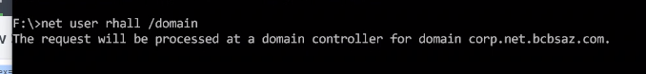

net user 'username" /domain | findstr "app name"

net user 'username" /domain | findstr "spl"

