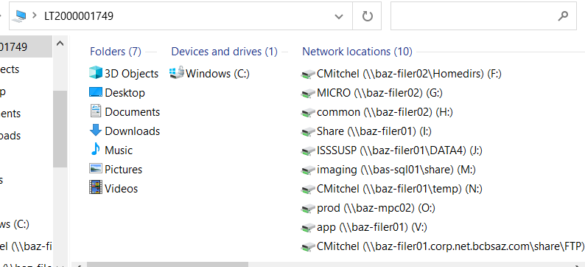

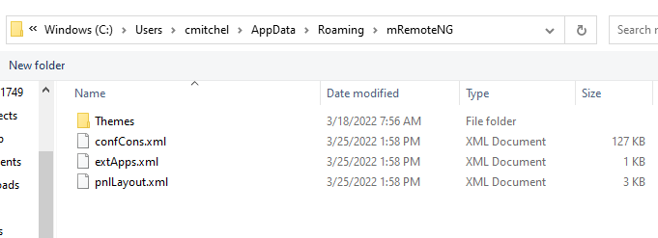

C:\Program Files (x86)\Microsoft\Remote Desktop Connection Manager