Patching Demo

When run this app it will create the spreadsheet



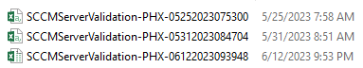

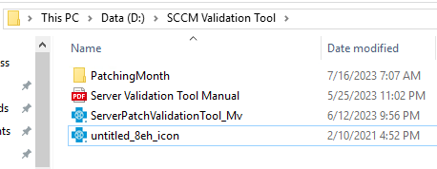

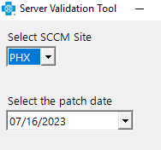

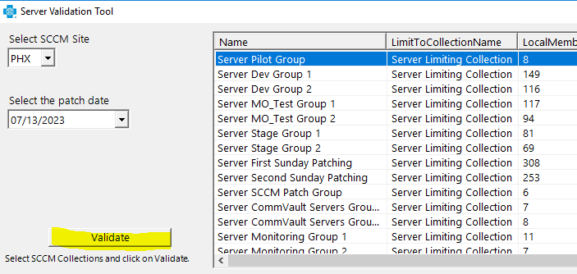

Validate – will take some time to run…..

Click export once done…..

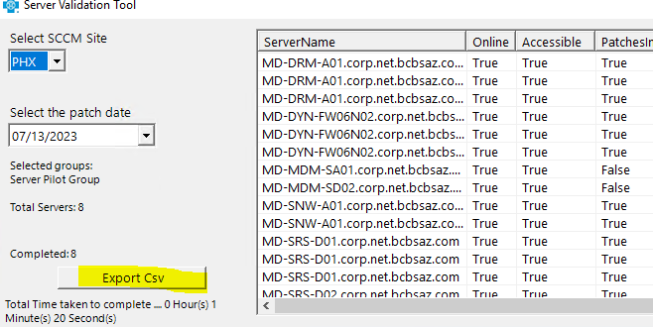

If you see false need to check the server

Run/search – type run click on check for update and view update history

If not go to software center

Updates

Click on install all if there something there…. Then it will reboot by itself…