Take server out of load balance

Reboot or restart IIS

Delete the ARP table

Take server back in to the Load Balancer…

OPS,

Here are some helpful tips to determine if the real servers are responding to the Netscaler.

In this example, we’ll investigate the azblue.com VIP (172.17.10.107)

Stay tuned for part2 email showing how to view and clear a real server ARP entry from the Netscaler.

Login to the Prod-DMZ17 Netscaler instance. Expand Traffic Manager -> Load Balancing -> Virtual Servers, click the Search feature in the upper right hand corner of the page



Search for azblue.com VIP IP address 172.17.10.107, hit enter

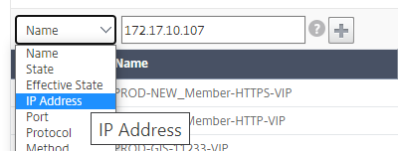

Results should look like this….

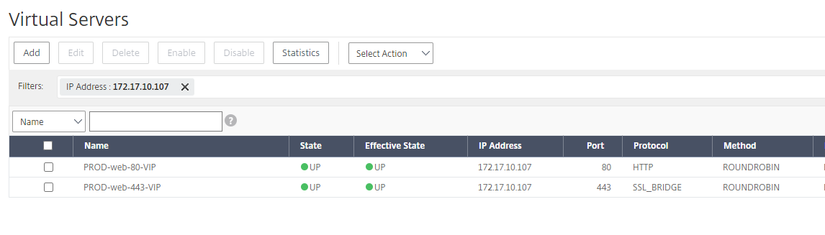

Hoover over and click on the elliptical next to the Prod-web-443-vip and select Statistics

cid:image005.png@01D6DDF1.18B12E10

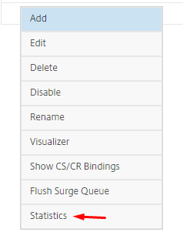

Scroll to the bottom of page and look for connections, all three nodes should be GREEN and report UP

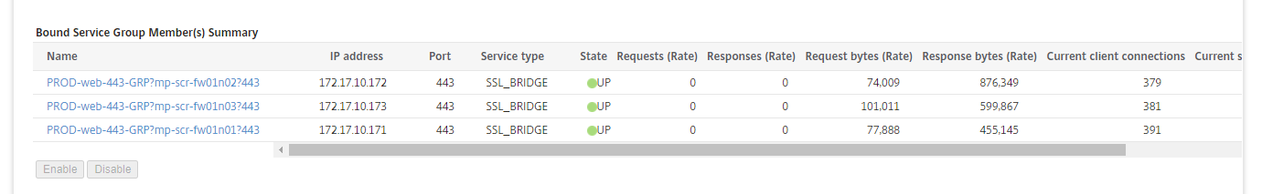

If a real server shows DOWN, make sure the real server IIS services are started.

Next we’ll check the real server ARP entries on the Netscaler.

Real server ARP entries are located under System -> Network -> Arp Table

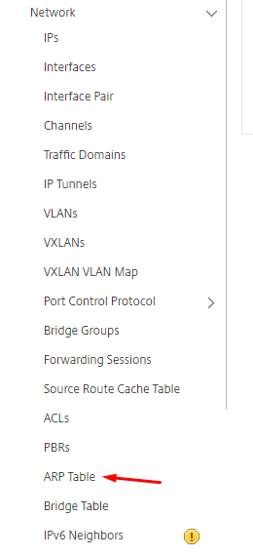

Sort IP address by clicking on the IP Address tab, search for the three SiteCore servers by IP address

Mp-scr-fw01n01 (172.17.10.171)

Mp-scr-fw01n02 (172.17.10.172)

Mp-scr-fw01n03 (172.17.10.173)

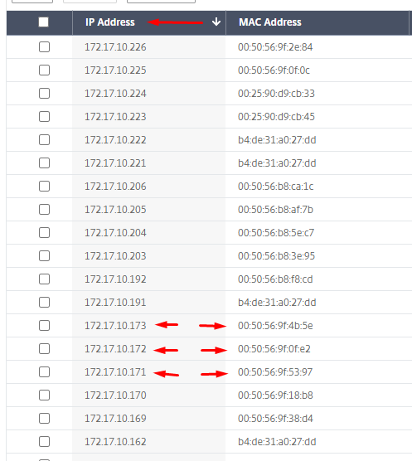

The DMZ17 network(s) are all layer2 and the only way to identify a real server IP address is through an ARP lookup.

We have seen where the Netscaler performs an ARP lookup for a real server IP address and the Netscaler receives the ARP entry of the FTD firewall.

Sometimes the Netscaler returns the ARP entry of the actual VMware real serer.

The differences in ARP entries:

VMware ARP entries start with 00:50

Cisco FTD ARP entries start with b4:de

We have also seen real servers stop responding to VIPs after a server is removed from load balancing and IIS services are restarted.

To get the real server to respond to the Netscaler, we have had to remove the real server ARP entry and allow the Netscaler to re-learn the real server IP/MAC address.

How to remove an ARP entry:

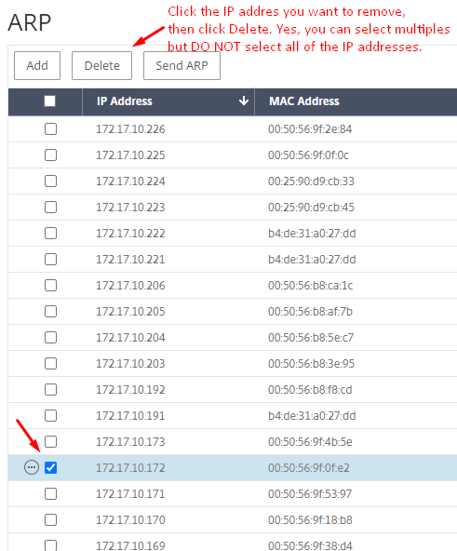

It’s worth repeating, **DO NOT** select all of the IP addresses when you delete ARP entries.

Refresh the page (in the upper right hand corner) and make sure the Netscaler was able to retrieve an ARP entry for the real host.

Don’t be surprised if the ARP entry is the same as the entry you just removed.

Go back to the azblue.com VIP (172.17.10.107), under statistics and verify the real server shows Green/UP status.

I’m researching how to permit Operations the ability to remove ARP entries from the DMZ17 Netscaler. I’ll send email part3 when I have the permissions worked out and we can start testing.

Thanks,

Chuck

OPS,

I made a slight modification to the OPS user group permissions on the Citrix DMZ17 Netscaler.

Everyone in Operations that has access to the DMZ17 Netscaler should now have the ability to remove ARP entries.

Gil tested this without any errors, but if you do encounter any problems please don’t hesitate to reach out to me.

Thanks,

Chuck