Splunk dropdown syntax:

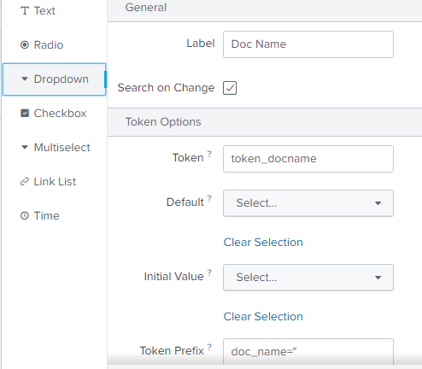

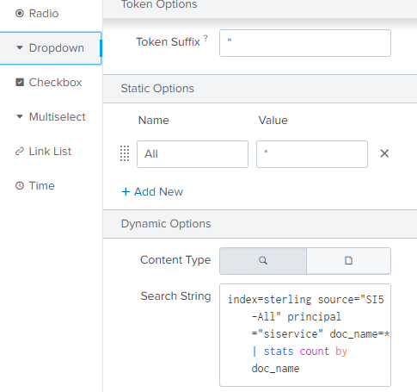

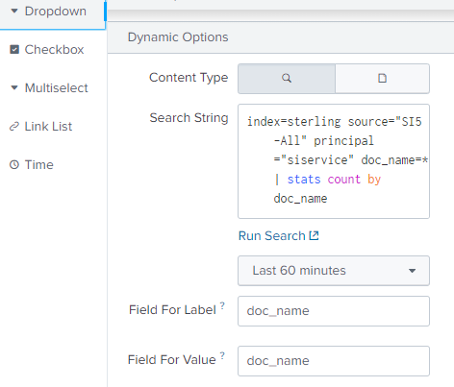

index=sterling source="SI5-All" principal="siservice" doc_name=* | stats count by doc_name

index=sterling sourcetype="SI5*" source="SI5-All" doc_name="*" $token_docname$

| eval FileSize(KB)=round(fileSizeBytes/1024,2)

| table connection_start_time principal doc_name FileSize(KB) state

| sort - connection_start-time

(index=sterling host="ms-si0-d01" sourcetype="SI5:Jobs" file_name="PX*") | stats count by file_name

index=sterling sourcetype="SI5*" source="SI5-All" doc_name="*" $token_docname$

| eval FileSize(KB)=round(fileSizeBytes/1024,2)

| table connection_start_time principal doc_name FileSize(KB) state

| sort - connection_start-time