**Restart Splunk Forwarder on a Unix box**

<https://docs.splunk.com/Documentation/Forwarder/8.0.4/Forwarder/Starttheuniversalforwarder>

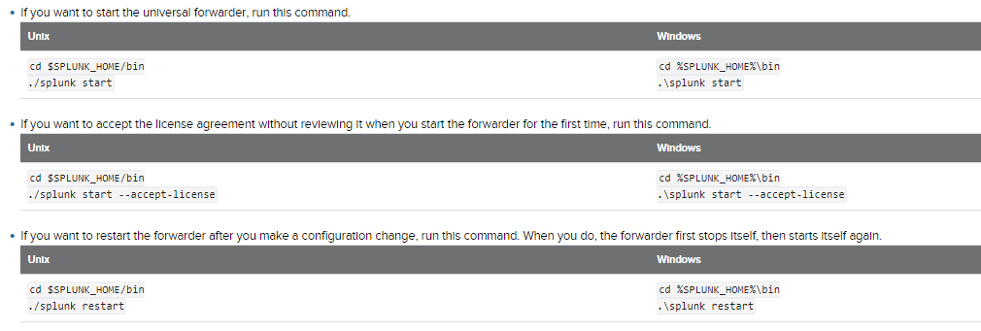

Root euur4{Ux=!

Then choose option 2

Corp\admincmitchel

(index=os sourcetype=cpu host="lp-ivr-*")

| timechart span=1h avg(pctUser) as "% CPU User" avg(pctSystem) as "% CPU System" avg(pctIowait) as "% CPU I/O" by host

Once you log in: LD-IVR-W01 (10.1.77.218) - putty

