AZure

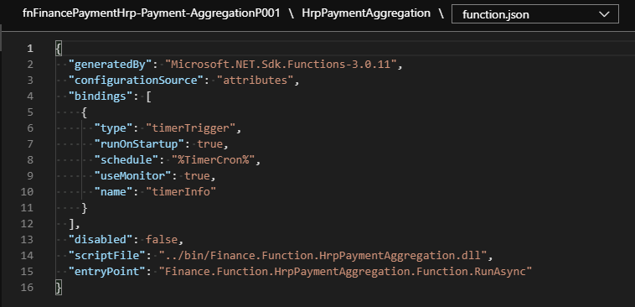

File is located in Azure : from the Inbound folder…. [7:59 AM] Soza, Gilbert

\\baz-filer01\share\EMFT_FTP\Inbound\HRP\EOP\Prod

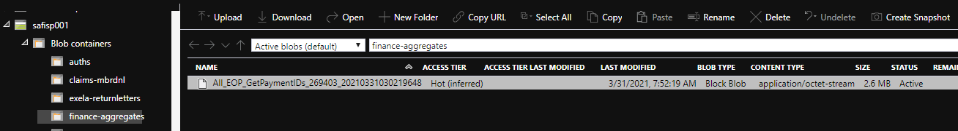

\\baz-filer01\share\EMFT_FTP\Outbound\RedCard\EOP\Prod - Zip land for SI5.