notes

**From:** Shorty, Rodney <[Rodney.Shorty@azblue.com](mailto:Rodney.Shorty@azblue.com)>   
**Sent:** Monday, June 13, 2022 10:24 PM  
**To:** Shorty, Rodney <[Rodney.Shorty@azblue.com](mailto:Rodney.Shorty@azblue.com)>  
**Subject:** EOP issue at SI column. issue with 1 redcard zip file, duplicate = with redcard delete ***notes

119453 = 847

119455 = 7

119456 = 3,113

119457 = 1,046

119536 = 4

119645 = 531

- - - - - - - - -

Total: 5,548

At 2055, HRP Database has

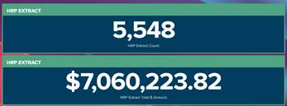

|  |  |  |
| --- | --- | --- |
| HRP Column | SI Column | Redcard Column |
| 5,548 | 2,435 |  |

Batch 119456 still processing in SI

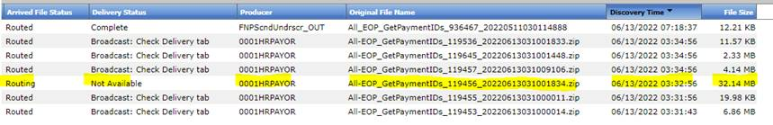

At 1032am, count updated

|  |  |  |
| --- | --- | --- |
| HRP Column | SI Column | Redcard Column |
| 5,548 | 2,595 |  |

Files getting to Directory: \\baz-filer01\share\EMFT_FTP\Inbound\HRP\EOP\Prod

Zip files into below directory

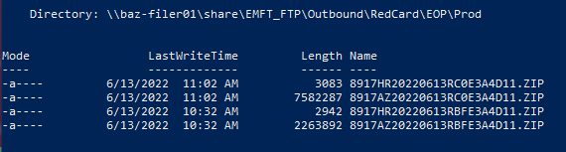

At 1032am, count updated

|  |  |  |
| --- | --- | --- |
| HRP Column | SI Column | Redcard Column |
| 5,548 | 3,698 |  |

At 114am, finally batch 119456 has routed

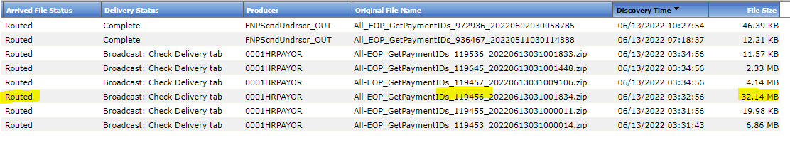

At 11:47am, count updated

|  |  |  |
| --- | --- | --- |
| HRP Column | SI Column | Redcard Column |
| 5,548 | 5,187 |  |

Velocity directory count at 5,548

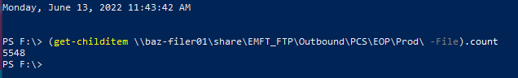

At 1403, files still in directory \\baz-filer01\share\EMFT_FTP\Outbound\RedCard\EOP\Prod

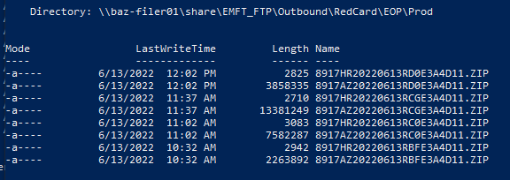

Can run JobID launch for 1520 and 1878  due to no use of IE browser

Had to ask Hung/Ryan to run jobs 1520 and 1878

                -Monday and Wednesday schedule is to run from 9 - 12:30 every 30 minutes

            -Tuesday, Thursday, Friday from 3 - 7:30PM

At 4:24pm, count updated

|  |  |  |
| --- | --- | --- |
| HRP Column | SI Column | Redcard Column |
| 5,548 | 5,548 | 4,979 |

*note: compare zellis e-mail with SI routed 3A4D11 zip files. Compare and contrast

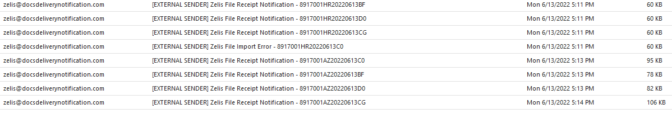

Missing file that K.Royer was asking for

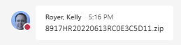

|  |
| --- |
| Was comparing |
| Mode                 LastWriteTime         Length Name  ----                 -------------         ------ ----  -a----         6/13/2022  12:02 PM           2825   8917HR20220613RD0E3A4D11.ZIP  -a----         6/13/2022  12:02 PM        3858335   8917AZ20220613RD0E3A4D11.ZIP  -a----         6/13/2022  11:37 AM           2710   8917HR20220613RCGE3A4D11.ZIP  -a----         6/13/2022  11:37 AM       13381249   8917AZ20220613RCGE3A4D11.ZIP  -a----         6/13/2022  11:02 AM           3083 8917HR20220613RC0E3A4D11.ZIP  -a----         6/13/2022  11:02 AM        7582287   8917AZ20220613RC0E3A4D11.ZIP  -a----         6/13/2022  10:32 AM           2942   8917HR20220613RBFE3A4D11.ZIP  -a----         6/13/2022  10:32 AM        2263892   8917AZ20220613RBFE3A4D11.ZIP  *8917HR20220613RBFE3A4D11.ZIP = 1  *8917HR20220613RD0E3A4D11.ZIP = 1  *8917HR20220613RCGE3A4D11.ZIP = 1      8917HR20220613RC0E3C5D11.zip (MHS document) = 1  *8917AZ20220613RC0E3A4D11.ZIP = 886  *8917AZ20220613RBFE3A4D11.ZIP = 323  *8917AZ20220613RD0E3A4D11.ZIP = 445  *8917AZ20220613RCGE3A4D11.ZIP = 1455 |

I:\EMFT_FTP\Outbound\RedCard\Production-Letters-SENT-TO-REDCARD

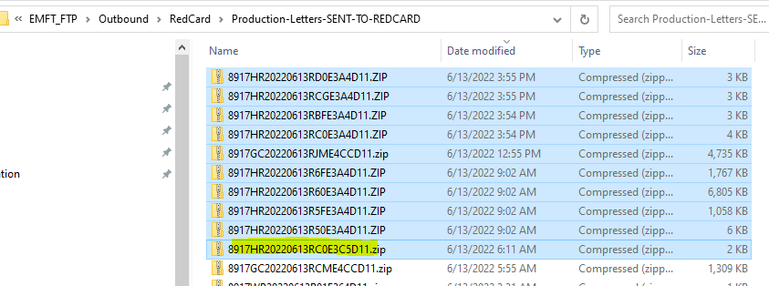

Logged onto MM-OPS-A03 to run

primary

<http://mp-si0-a06.corp.net.bcbsaz.com/eSolutions>

Backup

<http://mp-si0-a07.corp.net.bcbsaz.com/eSolutions>

I copied zip files form HR for today from directory

|  |  |
| --- | --- |
| HR zip files  I:\EMFT_FTP\Outbound\RedCard\Production-Letters-SENT-TO-REDCARD | AZ zip files  I:\EMFT_FTP\Outbound\RedCard\EOP\Prod\SENT-TO-REDCARD |
| Total of 8 HR zip files  At 3:45pm with 4KB, failed due to duplicate so renamed/resubmit at 6:20pm | Total of 7 AZ zip files |

Then ran script MM-OPS-A02\D:\Scripts\Redcard_zip_count_test\ Redcard_zip_count_test.Ps1

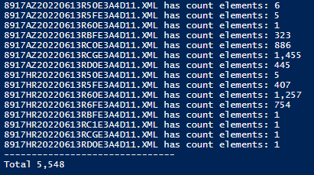

Count came out to 5,548. Orale!!

Now run the real script

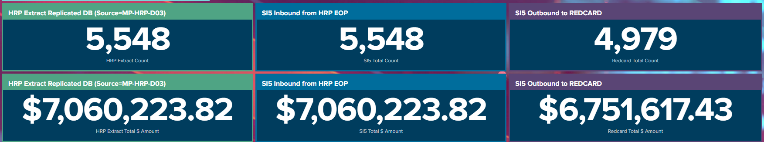

(index=sterling sourcetype="eop:redcard" host=mm-ops-a02) paymentThroughDate="2022-6-13" | delete

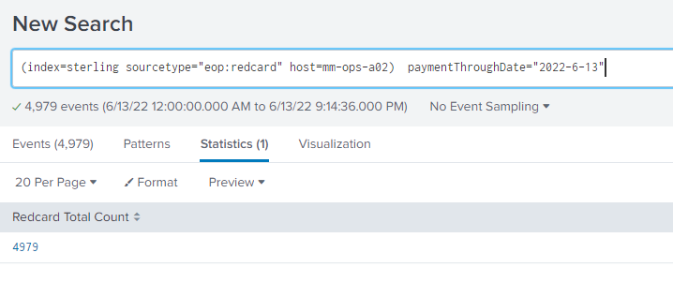

Ran delete command

Can’t run shit due to memory

Logfile. Where I started with small file



