Fred Lilikes

Nick Brink

Rob restart the Finance EOP function before we could redrop the files. The only other person that I know has access is Anna Koval.

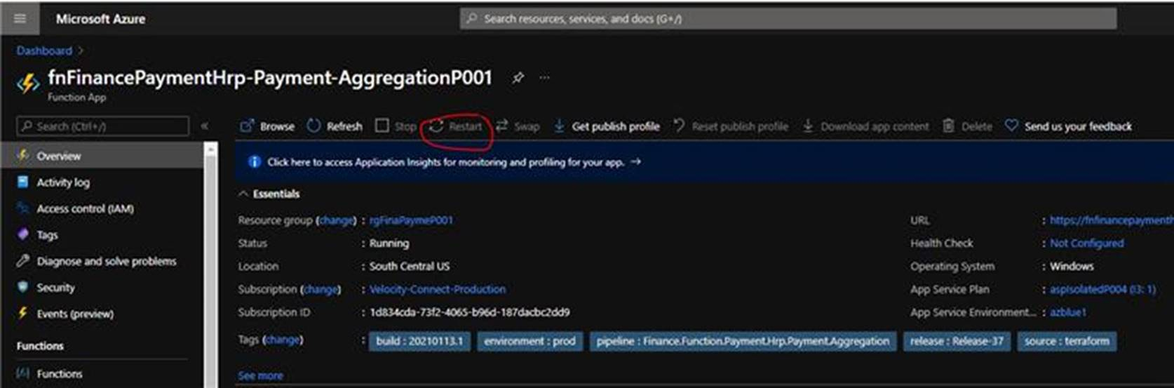

Yesterday we were lucky and it was two EOP zip files that didn’t process in Velocity and make it to Redcard.  This example was easy because we just had to grab the two zip files from \\baz-filer02\STArchive\SIProd\Archives\Inbound\zip_IN And copy them to mm-ops-a02 and unzip them to redrop to velocity.

The below is example is to be used if there was a partial processing of the zip files.  The below example shows you how to figure the paymentids that didn’t make it to Redcard and tie that back to the EOP file names Inbound from HRP.  We will need to follow this example so we can only grab the ones needed to redrop back into velocity.

1. Open in search the highlighted report to get a list of the paymentids that didn’t make it to Redcard.  Then export the events to a csv.

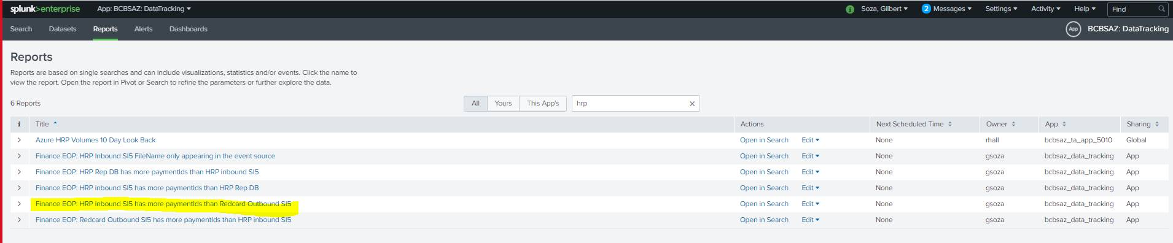

1. Open the csv and remove the headers.  Then add two columns a paymentId= and OR to have it look like the screen shot below. At the end of the list make sure there is no OR. Example Column C row 27.

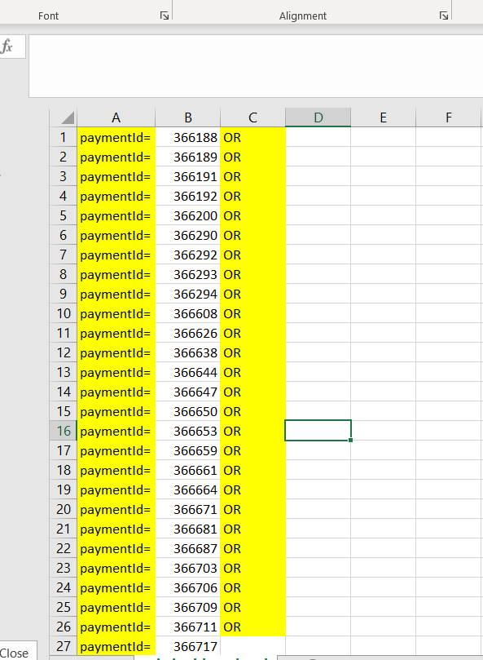

1. Now you will need the paymentids from the list you created to run this search in Splunk. The file_name will be used to get for your files.txt

(index=main OR index=sterling sourcetype="eop:hrp:prod")

paymentId=  367615          OR

paymentId=  367927          OR

paymentId=  367928          OR

paymentId=  367930          OR

paymentId=  367931          OR

paymentId=  367935          OR

paymentId=  367938          OR

paymentId=  367941          OR

paymentId=  367942

| rex field=source "(EOP\W)(?<file_name>\w+)"

| table file_name paymentId

1. Create a new folder for today’s payment cycle date on C:\finance_move.  Copy all eop zip files for today’s date from \\baz-filer02\STArchive\SIProd\Archives\Inbound\zip_IN to the folder you just created. Then unzip those to an all folder.  Then create a files.txt file and copy the movefiles.ps1 to that folder and update the powershell with the new folders for today’s date.  The script is going to search the all folder and only move the ones you need to redrop to the destination.  Then you will need to grab the eop files from the destination folder so that you can redrop them to Velocity \\baz-filer01\share\EMFT_FTP\Inbound\HRP\EOP\Prod.